ANNUAL REPORT 2020-21

Bureau of Outreach and Communication (BOC)
Bureau of Outreach and Communication (BOC) was set up on 8th December, 2017 by integration of erstwhile Directorate of Advertising and Visual Publicity (DAVP), Directorate of Field Publicity (DFP) and Song & Drama Division (S&DD). The Bureau aims at providing a 360 degrees communication solutions to the Ministries/Departments/ Public Sector Undertakings (PSUs)/autonomous bodies. It acts as an advisory body to Government on media strategy. With 23 Regional Outreach Bureaus (ROBs) and 148 Field Outreach Bureaus (FOBs), BOC is engaged in educating people, both rural and urban, about the Government’s policies and programmes to evoke their participation in developmental activities. This is ensured by the Bureau using different vehicles of communication viz. Print Media advertising, Audio Visual Campaigns, dissemination through Exhibitions, Outdoor Campaigns and New Media etc.
Branding of the Government as prime facilitator of people’s empowerment and positioning of messages through Print, Audio-Visual, Outdoor, Digital Media to realize the same, is BOC’s mandate. The Policy guidelines have been adapted in sync with emerging media scenario in order to maximize the reach of information dissemination.
Advertising and Visual communication Division (erstwhile DAVP) of BOC is the nodal division of BOC for dissemination of information about various schemes and policies of different Ministries & Departments of Government of India, Public Sector Undertakings (PSUs) and autonomous body.
It undertakes campaigns to inform and educate rural and urban people about the Government’s policies and programmes through available vehicles of communication viz. Print, Audio Visual, Outdoor, Digital and New Media.
Folk Communication Division of BOC carries out inter-personal communication through live media utilizing wide range of performing arts such as Drama, Dance-Drama, Composite-Programme, Puppetry, Ballets, Operas, Folk and Traditional Recitals, Mythological Recital and other Local Folk & Traditional Forms maximizing outreach of Policies, Programmes and Schemes of the Government. The main function is to create awareness and ensure emotional receptivity with the sense of belongingness and ownership.
Field Communication Division undertakes direct and interpersonal communication programmes to create awareness amongst the masses, particularly in rural and semi urban areas. Regional Outreach Bureau (ROBs) and Field Outreach Bureau (FOBs) accordingly seek to empower people through information to enable them to avail the benefits from such programmes/schemes. It organizes ground activation and outreach programmes. Special Outreach Programmes (SOPs) are organized with the support of various stakeholders viz. the State Government and local functionaries, society groups etc. As they are in the local language and at nearby venues, the impact of these communication programmes is more and it enables a greater understanding of the Government’s schemes among the masses. These efforts are complemented by use of traditional and folk media and other conventional and non-conventional methods.
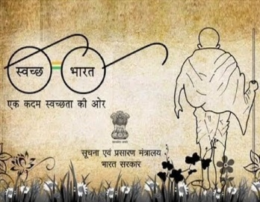
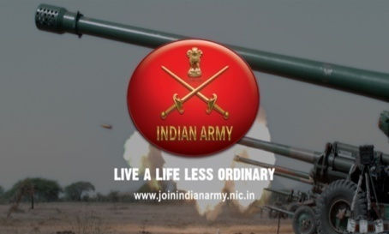
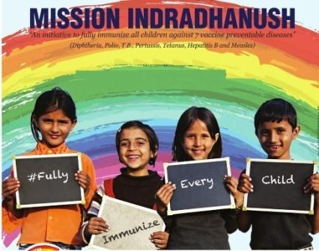
With integration of erstwhile DAVP, DFP and S&DD, programmes are increasingly organized in integrated manner with special outreach and folk components together. These Integrated Communication and Outreach Programmes (ICOP) aim at leaving a greater impact ensuring behavioural change and creating stakes in developmental process.
The BOC has been instrumental in creating awareness amongst masses on socio-economic themes, seeking their participation in developmental activities and for the eradication of many social evils. All possible channels of communication have been leveraged to reach out to the people, ranging from advertisements to street plays to door-to-door interactions making a paradigm shift from standalone and isolated advertising to 360 degree holistic campaign.
Our Mandate:
- Work towards creating an informed citizenry
- People Centric Communication approach
- Disseminate information on schemes and programmes of the Government of India, using different Media Vehicles
- Formulate Communication (IEC) strategy for the Government.
- Put in place appropriate policy framework for use of different media vehicles and determine rates for the same.
- Conducting Integrated Communication & Outreach Programmes (ICOP) at central, regional and rural levels
- Disseminate information on schemes and programmes of the Government of India by the means of folk art

ORGANISATIONAL STRUCTURE
The BOC is headed by a Director General (DG) with its headquarters at Soochana Bhawan, New Delhi. BOC operating from Delhi, ROBs from regions and FOBs at the field level are manned by officers of Indian Information Service and Ex-cadre personnel of erstwhile DAVP (Directorate of Advertisement Visual Publicity), Directorate of Field Publicity and Song & Drama Division. The personnel from multiple disciplines like media planning, production, studio design, Print production, exhibition, song and drama division are amongst others are the in house talent with expertise in handling campaign requirements of the client ministries.
Given the massive regional and linguistic diversity in India, the country has been divided into five zones, each headed by a DG level officer, below which there are regional offices and field offices. At the regional level, the media units are integrated into the Regional Outreach Bureaus (RoBs) with an Additional Director General level officer as the head of the department. The Field Outreach Bureaus (FoBs) at the local level are manned by Field Publicity Officers/ Field Publicity Assistants/ Field Exhibition Officers etc. At present the BOC has a network of 23 ROB’s and 148 FOB’s all across the country. All communication activities are undertaken in the regional languages as per the need of the campaign.
A 360-degree approach to awareness generation and behavioural change would require the flawless integration of both communication and outreach initiatives. BOC as a nodal government organization has been working tirelessly towards this goal for effectively taking the message of the Government of India to the people of the country.

FUNCTIONAL SET-UP OF BOC
BUREAU OF OUTREACH AND COMMUNICATION

COMMUNICATION
- CAMPAIGN WING
- ADVERTISING WING
- OUTDOOR WING
- PRINT WING
- AUDIO VISUAL WING
- NEW MEDIA WING
OUTREACH
- OUTREACH WING
- SONGS AND DRAMA WING
- EXHIBITION WING
OTHERS
- ADMINISTATION WING
- ACCOUNTS WING

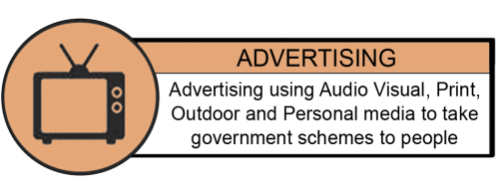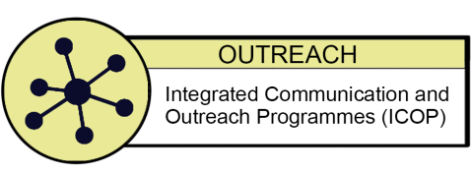
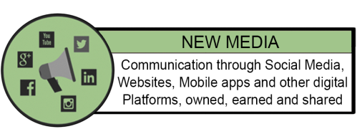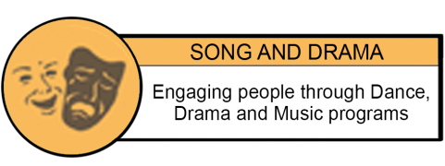
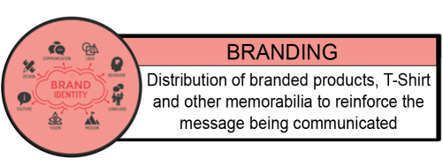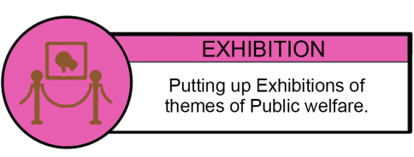
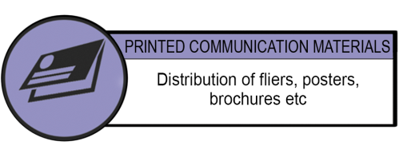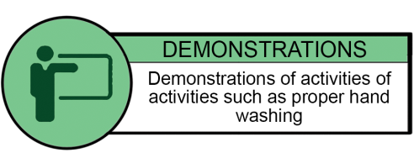
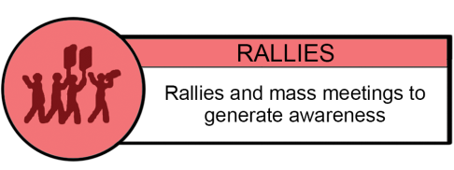
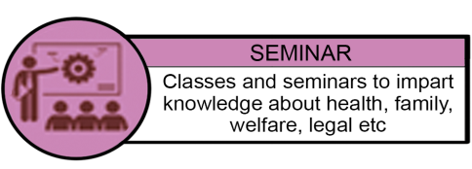
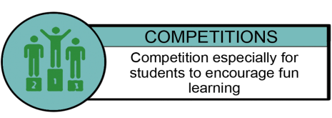

Highlights of the Year

- Republic Day Tableau: #VocalforLocal
- GoI Calendar and Diary App
- New India Samachar : Printing and Distribution
- COVID-19 Awareness Campaign through different mediums of social media viz: 1.Twitter, 2. Facebook, 3. Instagram, 4.Whatsapp, 5.Telephone Call, 6. SMS etc.
- Exhibition on Atal Bihari Vajpayee
- Booklet on the Theme ‘Putting Farmers First’
- Booklet on the Theme ‘Demonetisation a Multi Dimensional Success’
- Booklet on the Theme ‘PM Modi and his Government’s special relationship with Sikhs’
- Constitution Day Exhibition
- Booklet on the Theme ‘India’s Women Overcoming Challenges, Breaking Barriers’
- Special Awareness Campaign: Jab Tak Dawayi Nahi Tab Tak Dhilayi Nahi
- Ek Bharat Shreshtha Bharat
- National Unity Day Celebration: Print Media Campaign
- Gandhi Jayanti Celebration: Photo Exhibition and Print Media Campaign
- All India full page print advertisement released in prominent daily newspapers across India highlighting the benefits of New Farmer’s Bill.
- MOU with BECIL for complete automation of BOC’s activities starting from Empanelment of Vendor to Media Planning, Release of Campaign, Receipt of funds and Release of payment to the vendors.
- Social Media Campaign on the developmental activities in UTs Jammu & Kashmir and Ladakh
- 74th Independence Day – Half page colour Advertisement
- Webinar on Rescue Operation of Wildlife
- Webinar on the occasion of Kargil Vijay Diwas
- Webinar on increasing population
- Webinar on Mental Health in the time of COVID-19
- Webinar on COVID-19 Myths & Realities
- Print and Outdoor Media Campaign to commemorate the Kargil Vijay Diwas on the theme of 'Courage in Kargil'.
- Virtual Yoga Sessions on International Day of Yoga 2020
- Printing of first trial issue of New India Samachar in 13 languages.
- BOC Twitter handle achieves Milestone of 1 Million Impressions
- Aatmanirbhar Bharat Abhiyan- Print Media Campaign
- Print and Electronic Media campaign about Arogya Setu App launched by Government of India to assist people in the context of Covid-19 pandemic.

Important Activities:

Republic Day Tableau: #VocalforLocal

- Bureau of Outreach and Communication put up a tableau #VocalforLocal on the occasion of Republic Day Parade 2021 at Rajpath on behalf of Ministry of Information and Broadcasting.

- The theme of the tableau is ‘Vocal for Local’ which was a clarion call given by Hon’ble Prime Minister on 30th August 2020 to encourage use indigenous local products. The theme ‘Vocal for Local’ is encapsulated in various elements placed in the tableau.

- While aesthetics befitting the occasion are of paramount importance, this tableau endeavours to connect with youth using modern technologies of display. The depiction showcases the fact that the country is vocal not only about local consumption but also about local production.

- The front and the middle of the tableau consists of various locally produced items ranging from traditional Indian vase, khadi charkha, apparels such as jacket, jewellery, toys etc. through medicines such as Covaxin, HCQ; mobile phones, scooters, etc, to the high end technology products such as rocket, missile, robot, satellite and Tejas.

- Digital India is also captured by way of depiction through BHIM app and Mygov.in. Each of the four artistes on either side of tableau on ground and four artistes on tableau will symbolically represent person from six fields-farmer, doctor, artisan, space scientist, factory worker and software/start-up professional.

- The rear of the tableau consist a megaphone that symbolizes ‘vocal’ and the items at the front and middle seem to emerge from this megaphone, thereby resonating with the theme. The logos of Doordarshan and All India Radio on megaphone symbolize the endeavour to propagate the theme of ‘Vocal for Local’ as a Jan-andolan.

Digital Calendar & Diary of Government of India:

- In sync with decision of Government of India towards adopting digital technological innovations which is also economical, efficient and effective, BOC has developed a Digital Calendar and Diary App of Government of India for the year 2021.

- It is first Digital Calendar of the Government of India in line with the Prime Minister’s Vision of “Digital India”. It will provide latest information on various schemes, events and publications of the Government of India. Official holidays and various important dates can also be accessed.

- It allows users to take notes digitally which will be stored with best measures of security and privacy. Application is currently available in Hindi and English language, and will be made available in other 11 Indian regional languages in coming updates.

- It also helps in scheduling the meetings and setting reminders for important tasks and events. The application will also be made accessible for our Divyangjans in coming days in line with our Hon’ble Prime Minister’s goal of “Accessible India”.

New India Samachar
- To disseminate information on the initiatives and schemes of Govt. of India, a fortnightly titled “New India Samachar” was started by BOC.

- New India Samachar is an endeavour to provide correct information about various initiatives taken by Government of India for benefit of the common people. It educates and informs the readers with cabinet decisions, Mann ki Baat and give insight into topical issues in its unique way.

- The fortnightly is being printed in 13 languages and 4 lakh copies are distributed to all Gram Panchayats, Zila Parishads, Blocks, people’s representatives in Parliament and State Legislatures, Union Ministers, Governors, Chief Ministers, Secretaries, Educational Institutions, senior functionaries of State Government etc. The first trial issue was printed in the month of June 2020.

- First and Second public issue (15-31st August, 2020 and 1 -15th September, 2020) of New India Samachar was printed and distributed in the month of August.

- First public issue of NIS (15-31st August, 2020) talked about the path breaking New National Education Policy and second public issue covered the speech of Prime Ministers from the ramparts of Red fort on the occasion of 74th Independence Day.

- E-versions of New India Samachar are sent to more than 6.40 cr readers in flip book as well as PDF format in all 13 languages via emails using E-Sampark platform of MyGov India. As per E-Sampark, the total read of campaign is categorized as a high impact email campaign with total read percentage varying from 12% to 16% for different issues.

- Banner of New India Samachar is hosted on homepage of all Government websites including Ministries, Departments and PSUs with built in e-magazine in all 13 languages.

Awareness Campaign on COVID-19:

- BOC carried out massive awareness campaign to combat the spread of Novel Corona Virus (COVID-19) to make people aware about the symptoms of COVID-19 infections as well as preventive measures to be followed through Print, Television, Radio and different mediums of Social Media.

- This also includes advertisements about Arogya Setu App launched by Government of India to assist people in the context of Covid-19 pandemic and to maximize the reach of information regarding Arogya Setu app.

- Since April, 2020, 148 Field Outreach Bureaus (FOBs) and 23 Regional Outreach Bureau of BOC continued their awareness campaign on various aspects of Novel Corona Virus (COVID-19) through different mediums of Social Media viz; Telephonic Calls, SMS, Facebook and Instagram Posts, Tweets on Twitter and Whatsapp Messages/Videos. The details are as under:

1. | Total No. of Tweets and Retweets (with ‘Impressions’) | 1091968  (13088251)
2. | Total No. of Facebook Posts | 538120
3. | Total No. of Instagram Posts | 125586
4. | Total No. of Posters/ Message /Videos circulated on WhatsApp | 1449885
5. | Total No. of Telephonic Calls made by ROB | 280504
6. | Total No. of SMS sent by ROB | 296928
7. | Total No. Webinars | 453

- These awareness campaigns contained the themes like social distancing, strict adherence to lock- down guidelines, importance of downloading Arogya Setu app, when to go for home- quarantine, when Corona- test is needed, Regular Hand Washing and frequent Sanitizing, Wearing Mask as well as Making of Masks, different GOI Decisions and Initiatives, Myth Busters, Fake News Alerts, Experts Advise on issues related to COVID-19.

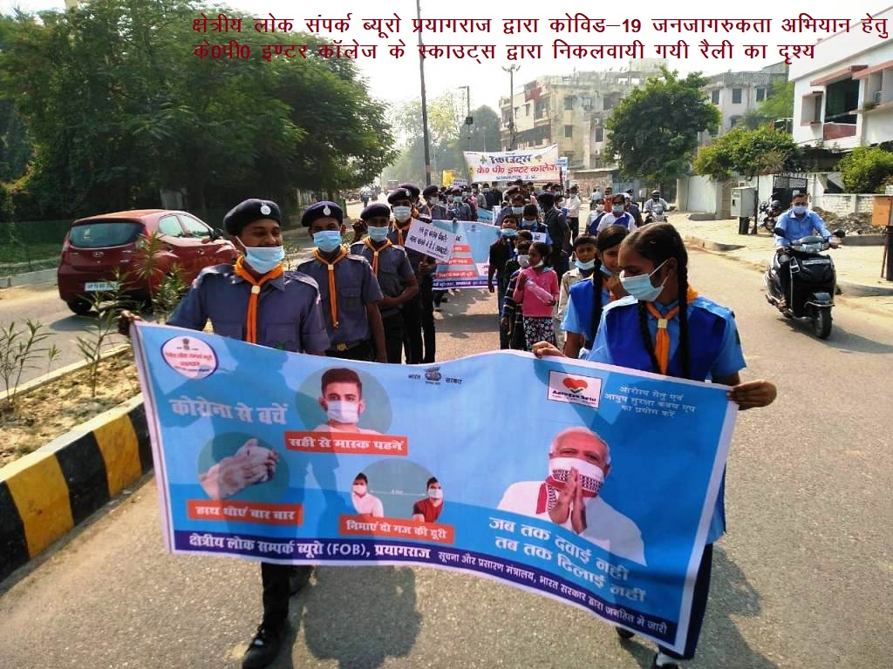
COVID-19 Awareness Rally
Exhibition on Atal Bihari Vajpayee
- BOC organized an exhibition on the Birth Anniversary of Atal Bihari Vajpayee on 25th December, 2020. The theme of the Exhibition was “Vikas Purush Atal Bihari Vajpayee”. Exhibitions were organized at Dr. Ambedkar International Centre and Soochna Bhawan New Delhi.

Booklet on the Theme ‘Putting Farmers First’:

- BOC printed and distributed a booklet named ‘Putting Farmers First’ highlighting the historic reforms introduced by the Government in the agriculture sector and benefits being introduced for farmers through recent three Farm laws.

- This booklet disseminates the right information about new farm laws. It will clear the doubts and misinformation that has spread about the laws and will present a correct picture.

- It also dispels the concerns and gives a detailed account of consultation that had taken place with various stakeholders over a period of time. The booklet also comprehensively covers various steps taken by the Government in the last six years for the welfare of farmers.

- The booklet has been printed in Hindi, English and 10 other regional languages. The same has been sent to ROBs/FOBs for further distribution among the general masses.

Booklet on the Theme ‘Demonetization a Multi Dimensional Success’:
- BOC printed a booklet enumerating various achievements of historic demonetization decision taken by the Government.

Booklet on the Theme ‘PM Modi and his Government’s special relationship with Sikhs’:
- BOC printed and distributed a booklet named ‘‘PM Modi and his Government’s special relationship with Sikhs’ in English, Hindi and Punjabi on the occasion 551st Birth Anniversary of Shri Guru Nanak Dev ji.

Constitution Day Exhibition:
- Participating in 80th all India presiding officers conference Bureau of Outreach and Communication organised a multimedia exhibition on 25th & 26th November titled “Constitution Day 2020” at Kevadiya Gujarat.

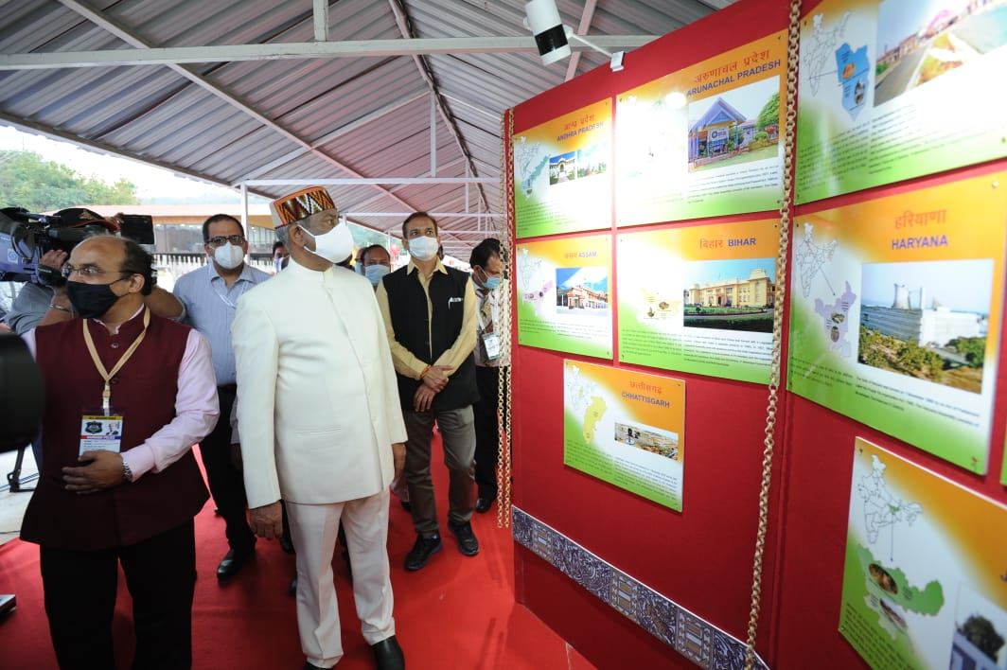
Hon’ble Speaker Loksabha taking a view of the Exhibition on Constitution Day

- Exhibition was inaugurated by Hon’ble Speaker Shri Om Birla on 25th Nov. The exhibition traced the Journey of democratic tradition in the country right from Vedic Times through the Lichchavi Republic to the making Modern India.

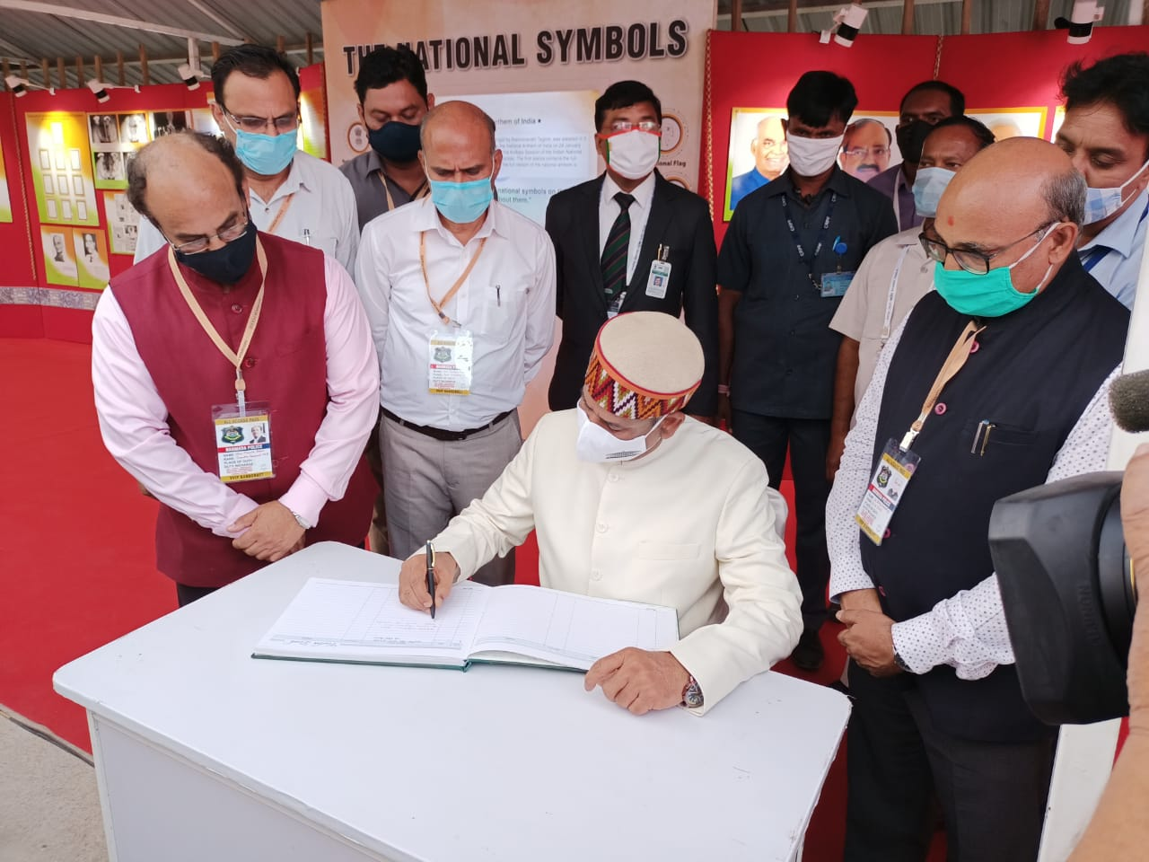
Hon’ble Speaker Loksabha writing his feedback in visitors book.
- Exhibition carried panels as well as Plasma display, interactive flip book, RFID card reader, interactive Screen & Digital Touch Wall etc.

Booklet on the Theme ‘India’s Women Overcoming Challenges, Breaking Barriers’:
- BOC printed a booklet on the theme ‘India’s Women’ based on Government’s women centric welfare initiatives and the women achievers of India.

Special Awareness Campaign: Jab Tak Dawayi Nahi Tab Tak Dhilayi Nahi
- A Special Awareness Campaign was launched by BOC on 7th October, 2020 to create awareness towards precautions to be taken to avoid spread of COVID-19. The theme of the campaign was Prime Ministers appeal of ‘Jab Tak Dawayi Nahi Tab Tak Dhilayi Nahi’. Hoarding, Banners, Posters, Standees were displayed across Delhi and particularly in the Government Offices. The campaign was also carried out across the country by different mediums of awareness including announcement through moving vans.

Ek Bharat Shreshtha Bharat:
- Ek Bharat Shrestha Bharat (EBSB) is a flagship initiative of the Government of India to celebrate the idea of India as a nation wherein different cultural units across varied geographies coalesce and interact with each other. The glorious manifestation of diverse cuisine, music, dance, theatre, movies & films etc. enables people to imbibe the innate chord of binding and brotherhood. The programme is being implemented with the objective of strengthening the engagement among all the Indian States/UTs through pairing.

- FOBs/ROBs also organized 60 webinars on EBSB on different topics like: ‘Fetivals of the States’, ‘How the constitution helps to maintain the integrity and unity of the Nation’, ‘Cultural Tradition and Activities’, ‘Rajasthani and Assami literature’, ‘ Rajasthani & Assami Dance Tradition’, ‘India Integrated by literature: The Bengal story celebrates the unit of diversity’, ‘My Idea of National Integration’, ‘Weaving Cultural Threads: Goa and Jharkhanda’, ‘Role of constitution in Maintaining Unity & Integrity of India’, ‘National Unity Day and Youth’,’National Unity Day’ etc., thereby promoting Ek Bharath Shrestha Bharath to implement the objective of strengthening the engagement between all the Indian States/UTs through pairing.

- FOBs/ROBs conducted quizzes, elocutions, paintings, patriotic songs and essay writing competitions on EBSB through social media components i.e Face book, Twitter, WhatsApp and Instagram etc., for increasing awareness among the students and the younger generation particularly.

National Unity Day Celebration:
- BOC issued a colour Print advertisement in Publications across the country on October 31st to commemorate the Birth anniversary of Sardar Vallabhbhai Patel which is celebrated as National Unity Day.

Gandhi Jayanti Celebration:
- BOC issued a Colour Print Advertisement in Publications across the country on October 2nd to commemorate Gandhi Jayanti and Shastri Jayanti.

- A Photo Exhibition was also organized in the Soochana Bhawan foyer on Mahatma Gandhi from 2nd October, 2020.

Campaign on New Farmer’s Bill:

- A Pan India full page print advertisement was released in prominent daily newspapers across India on behalf of Ministry of Agriculture highlighting the benefits of New Farmer’s Bill. The advertisement highlighted the clarity and affirmation w.r.t. continuation of Minimum Support Prices (MSP), continuation of Mandi System, clarity on fact that the sell, lease and mortgage of farmer’s land are completely prohibited and agreement is for the crop not of land.

MOU with BECIL :

- Bureau of Outreach and Communication signed a Memorandum of Understanding with Broadcast Engineering Consultants India Ltd for complete automation of BOC’s activities starting from Empanelment of Vendor to Media Planning, Release of Campaign, Receipt of funds and Release of payment to the vendors.

Social Media Campaign on the developmental activities in UTs Jammu & Kashmir and Ladakh:
- On the occasion of the first anniversary of J&K Reorganisation act, 2019 a social media campaign was conceptualized and designed by BOC for informing the developmental and welfare activities that took place in the region in the last one year. BOC designed posters for various social media platforms and web banners. The creatives were shared with various Media Units and a coordinated campaign was carried out.

74th Independence Day – Half page colour Advertisement
- BOC issued a half page colour Print advertisement in approx 1500 leading Newspapers and quarter page in approx 4500 Newspapers including Periodicals on the occasion of 74th Independence Day in 6013 Dailies and periodicals empanelled with BOC in 30 Indian Language across the country.

Webinar on Rescue Operation of Wildlife:
- ROB Shillong and its 4 FOBs also participated in the webinar on Rescue Operation of Wildlife in Kaziranga National Park organised by the PIB, Guwahati through video conferencing on 22.07.2020 and Cultural symbiosis between Rajasthan and Assam under EK Bharat Shreshtha Bharat on the 28.07.2020.

Webinar on the occasion of Kargil Vijay Diwas:
- On the occasion of Kargil Vijay Diwas i.e. 26th July, 2020 a webinar was also organized by ROB Pune.

Webinar on increasing population
- In the month of July 2020 ROB Bhopal organized two webinars on 11 and 30 July, 2020 on the subject increasing population with upcoming challenges and COVID-19.

Webinar on Mental Health in the time of COVID-19:
- On 23rd July, 2020 ROB Pune organized a Webinar on Mental Health in the time of COVID-19.

Webinar on COVID-19 Myths & Realities

- In view of the on-going pandemic of COVID-19, Regional outreach Bureau (Maharashtra & Goa region) organised a webinar on the topic of COVID19 – Myths & Realities on the occasion of the National Doctors’ Day 2020 i.e. on 01st July 2020.

Kargil Vijay Diwas Print and Outdoor Media Campaign

- To commemorate the Kargil Vijay Diwas BOC carried out campaign on the theme of ' Courage in Kargil 'during the month of July2020. In this connection an advertisement was published in prominent newspapers and also displayed on outdoor media.

International Day of Yoga:

- On the occasion of International Day of Yoga 2020 virtual Yoga sessions were carried out across the country by Regional Outreach Bureaus and Field Outreach Bureaus of BOC through Digital-Social platforms like YouTube, Facebook, Twitter and Instagram. Common Yoga protocol was displayed and practiced during virtual Yoga Sessions and webinar on the day by different ROBs and FOBs.

- Through these Yoga Sessions general masses were encouraged to practice Yoga from their homes and promote & popularize the “My Life – My Yoga”

BOC adopted new ways of message dissemination and creating awareness

- BOC adopted new ways of message dissemination and creating awareness on the evolving topics in the changed scenario. Field activities among the general masses were not possible in the wake of pandemic as such field units of BOC are adopting new means of awareness creation without physical contact and mass gathering.

- In the very beginning of the pandemic Regional and Field Bureaus of BOC started its awareness campaign through various mediums of social media like facebook, twitter, instagram, whatsapp, youtube etc. Further general masses are being made aware of the new programmes and policies of the Government as well as different relevant topics through webinars. In the month of July different ROBs and FOBs organized webinar on subjects like COVID-19 Myths & Realities, Mental Health in the time of COVID-19, Kargil Vijay Diwas, Rescue Operation of Wildlife.

BOC Twitter handle achieves Milestone of 1 Million Impressions:
- During the month of May, 2020, Twitter handle of BOC HQ earned a total of 1 Million impressions. Tweets from HQ handle included the campaign run by BOC, pan India work done by ROBs/FOBs in the region and authentic information regarding COVID-19 from government sources.

Aatmanirbhar Bharat Abhiyan Campaign:

- BOC launched an all India print media campaign during the month of May, 2020 to propagate the message of Atmanirbhar Bharat among masses in general and stakeholders in particular. This campaign aimed at making masses and stakeholders aware of intended benefits as well as details of the schemes.

- The campaign targeted Farmers, Migrants, MSMEs and Shopkeepers and explained the concrete steps taken by the Government to ease the difficulties faced by them due to COVID 19 pandemic.

- Atmanirbhar Bharat Campaign continued in the month of June also. The campaign in this month focused on MSME’s and Migrant Labour.

Aarogya Setu App Print and Electronic Media Campaign:

- BOC carried out a series of advertisements about Arogya Setu App launched by Government of India to assist people in the context of Covid-19 pandemic. The campaign was undertaken on Print and Electronic Media including Private TV Channels and Doordarshan, in the media campaign in order to maximize the reach of information regarding Arogya Setu app.

Jagriti Rath (Mobile Van)

- Some of the ROBs across the country have also disseminated information through COVID Jagriti Rath( Mobile Van)/ Auto Rikshaw/ E-Rikshaw/ Tri Cycles, with pre-recorded audio clips and messages to create awareness about COVID-19.

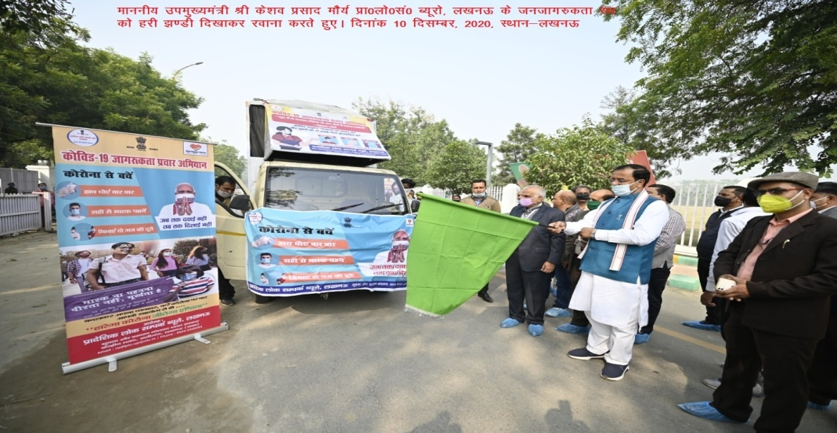

- The content of the messages were: Need for social distancing, strict adherence to lock- down guidelines, importance of Arogya Setu app/have downloaded Arogya Setu app, when to go for home- quarantine, when will Corona- test be needed. Regular Hand Washing & sanitizing frequently, Wearing & Making of Masks, GOI Decisions and Initiatives including Pradhan Mantri Garib Kalyan Yojana (PMGKY), Pradhan Mantri Garib Kalyan Ann Yojana (PMGKAY) & Pradhan Mantri Garib Kalyan Rojgar Abhiyaan(PMGKRA), Myth Busters, Fake News Alerts, Experts / Advise on issues related to COVID-19.
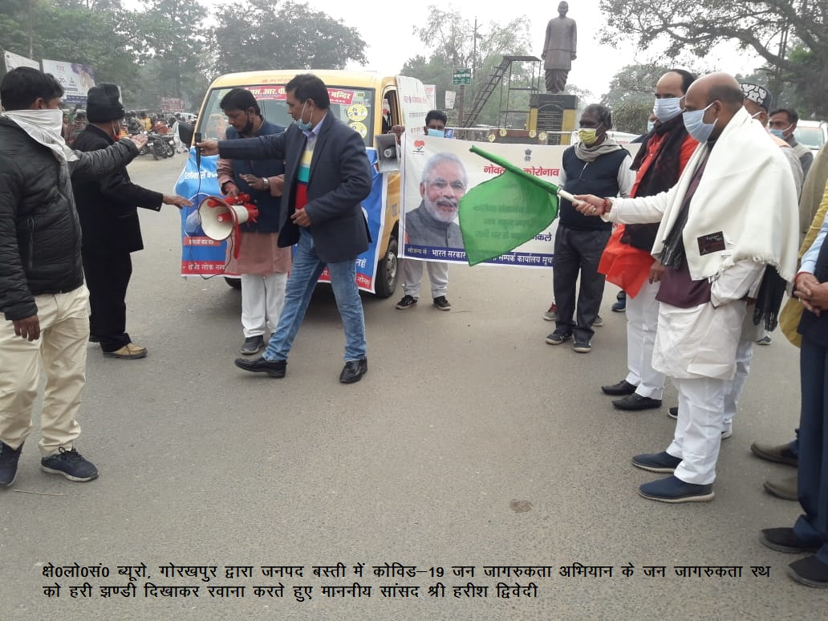
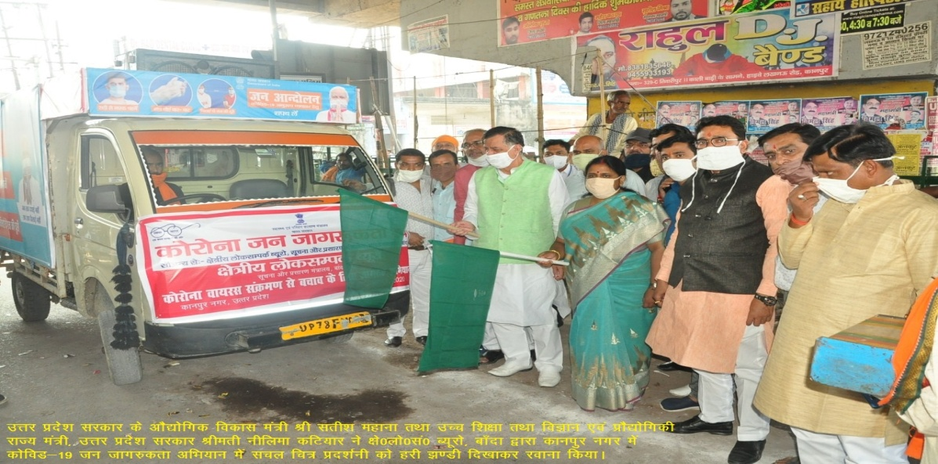
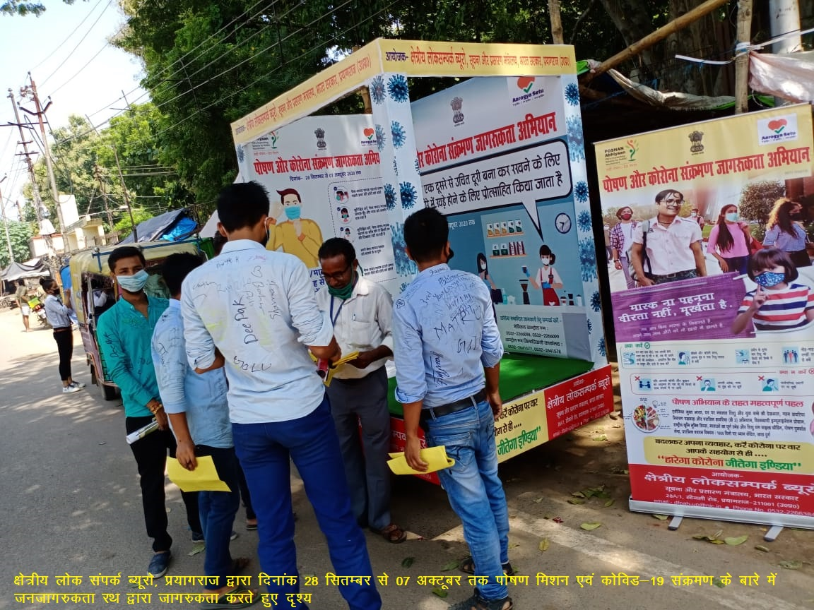
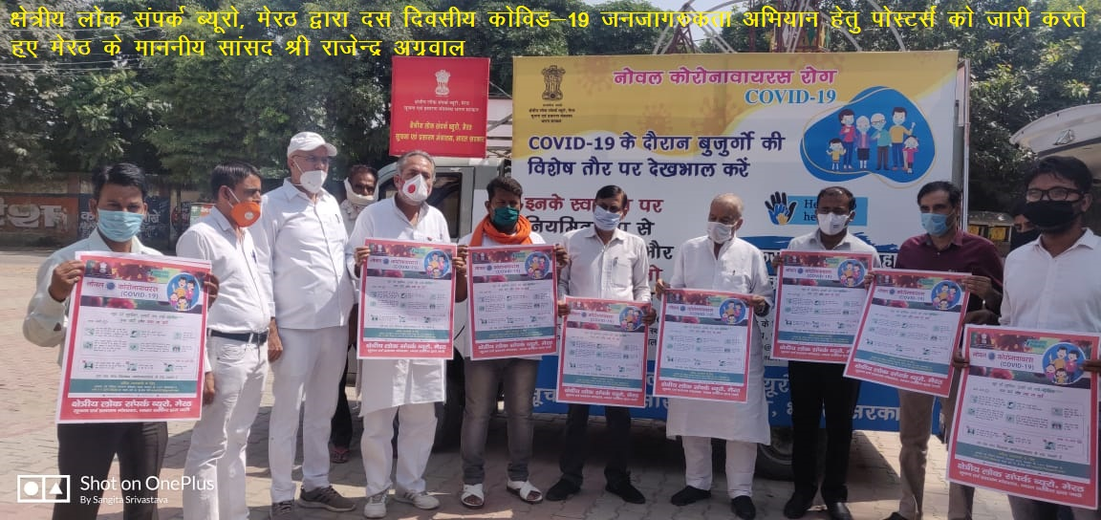

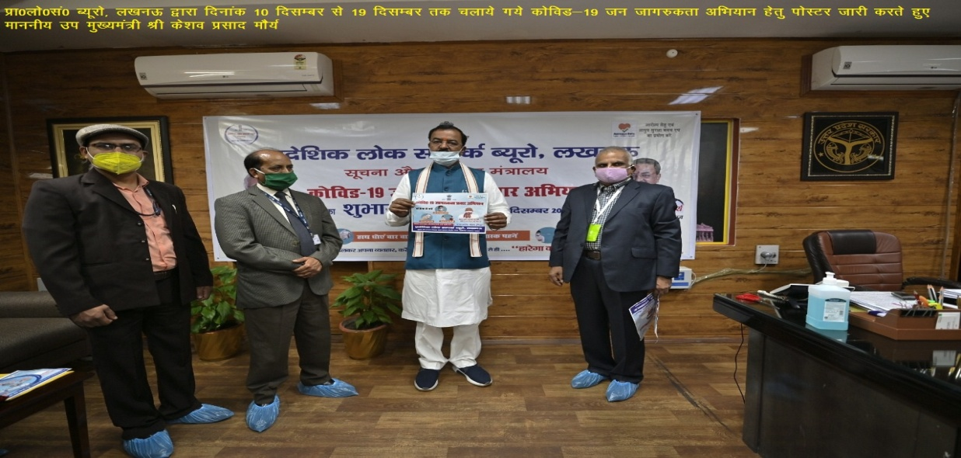

2. Other Awareness Activities by ROBs/FOBs:

i. Awareness Campaign through Social Media:-
Since April, 2020, during the COVID-19 Pandemic, 148 Field Outreach Bureaus (FOBs) and 23 Regional Outreach Bureau(ROBs) under BOC conducted awareness on various aspects of Novel Corona Virus (COVID-19) through Social Media across the country. ROBs have been disseminating information to the masses through Social Media/ digital mode viz. Telephonic Calls, SMS, Face book posts, tweets and re-tweets in Twitter, messages and posters through Whats app & Instagram and through Webinars on various aspects of Novel Corona Virus (COVID-19) and also informing the masses about taking precautions to keep themselves safe from Novel Corona Virus.

ii) On line competitions: -
ROBs organized various competitions through online virtual platforms, which included Yoga Video competition, Essay Writing, drawing and Quiz competitions by coordinating with district administration, Schools and Colleges. As a prelude to the events, the emphasis was on promoting the video blogging contest organized by Ayush Ministry on various platforms of ROB.

iii) Webinars:-
During the period from April to November,2020, ROBs have organized 453 Webinars on COVID-19, Jan Andolan to ensure COVID appropriate Behavior, National Education Policy, 2020, Fight Against Fake News, Honoring the Honest: Transparent Tax Assessement Scheme, Ek Bharat Shrestha Bharat, Pradhan Mantri Jan Dhan Yojana, Atma Nirbhar Bharat, Pradhan Mantri Garib Kalyan Yojana, & National Recruitment Agency, Poshan Maah, Agriculture Reforms and 150th Birth Anniversary of Mahatma Gandhi, International Day of Non-Violence and National Unity Day.

3. Observation of important National and International Events/Days/Week by ROBs and FOBs-

The Field Outreach Bureaus (FOBs) under Regional Outreach Bureaus (ROBs) highlighted various schemes of the Government in its routine activities while observing important National and International events/Days/weeks.

During the period from April, 2020 to November, 2020, the FOBs under ROBs observed the following Days/weeks through social media and disseminated the important messages on various flagship programmes of Government of India.

The important Days/weeks observed were: Anti terrorism Day, World No Tobacco Day, World Environment Day, International Yog a day, World Population Day, Kargil Vijay Diwas, Quit India Movement, Independence Day Celebration,Poshan Mah, Sadbhavna Diwas/week, 150th Birth Anniversary of Mahatma Gandhi, Gandhi Jayanti, International Day of Non-Violence, National Unity Day, the constitution Day etc.

i) International Day of Yoga: - During the month of June, the International Day of Yoga (21st June, 2020) was observed by All Regional Outreach Bureau (ROBs) / Field Outreach Bureau (FOBs) through social and digital media platforms like YouTube, Face book Twitter and Instagram etc to encourage people to pursue Yoga from their homes and promoting & popularizing the “My Life – My Yoga” (also called ‘Jeevan Yoga’. The video blogging contest organized by Ayush Ministry on the event was promoted on various platforms of ROBs.

During the occasion, ROBs organized Online Virtual Yoga Sessions on the day, in which all officials of ROBs/FOBs and PIBs were connected where Common Yoga Protocol were displayed and practiced. Experts from prominent Yoga Organization and Journalists also participated in the live Yoga Demonstrations. Some ROBs also organized Webinars on the topics like "Relevance of Yoga in the context of pandemic COVID19", ‘Yoga and Mental Health’ etc.
ii) Gandhi Jayanti: - Gandhi Jayanti (The International Day of Non-Violence) was observed by all FOBs/ROBs through social and digital media platforms like YouTube, Face book Twitter and Instagram etc. The day was celebrated as a part of celebration of 150th Birth Anniversary of Mahatma Gandhi and spread the philosophy & ideology of Mahatma Gandhi among the masses and the younger generation; in particular to the school and college students. Due to COVID-19 pandemic situation FOBs/ROBs could not conduct any outreach activities in the field on the above theme during this period. But all FOBS/ROBs organized number of webinars on the life and teachings of Mahatma Gandhi and also organized social media campaigns on Gandhian thoughts/quotes/pictures/short video clips etc,.

- Constitution Day: the Regional Outreach Bureaus (ROBs) under Bureau of Outreach & Communication (BOC) organized oath taking ceremonies in their respective office premises and read out the Preamble to Constitution on the occasion of Constitution Day on 26.11.2020. Online talks and discussion were organized on the eve of 71 years of the adoption of the Indian Constitution day as part of ‘Celebrations of the Constitution Day and Citizens’ Duties Campaign’ to create awareness on Constitution Day and Fundamental duties.

From April, 2020 to November, 2020, due to Covid-19 pandemic situation, ROBs could not organize field level programmes like ICOPs/Exhibitions/Cultural programmes. However, ROBs conducted number of webinars on the themes related to ‘Constitution of India’ and ‘Fundamental duties of Citizens’. They also conducted quiz, elocution, painting and essay writing competitions on the theme through social media components i.e Face book, Twitter, Whatsapp and Instagram etc. for increasing awareness among general public and the younger generation particularly.

4. Poshan Maah – Nutrition Month:-

Field Outreach Bureaus (FOBs) and Regional Outreach Bureaus(ROBs) of BOC observed the Poshan Maah during September, 2020 conducted publicity awareness programmes through Covid Vijaya Rath/ auto-rickshaw ensuring social distancing in the era of COVID-19 pandemic, on importance of POSHAN Abhiyaan (National Nutrition Mission) with a message to improve nutritional status of children up to 6 years, adolescent girls, pregnant women and lactating mothers to achieve specific targets for reduction in low birth weight babies, stunting growth, under nutrition and prevalence of anemia. The publicity activities included auto announcement, putting up of banners, slogan writings/paintings etc.
From April, 2020 to November, 2020, FOBs/ROBs organized number of webinars on “ Nutrition Week and Poshan Maah” related topics. Some of the topics are ‘Rastriya Poshan Maha’, ‘National Nutrition Week/Poshan Maah-2020’, ‘Food and Nutrition during COVID-19’, ‘Establishment of Nutrition Surveillancesystem in India on the occasion of Poshan Maah celebration’, ‘National Nutrition Mission’, ‘Healthy Diet Healthy Life’, ‘ Poshan Ke Paanch Sutra’, ‘Poshan Bharat Abhiyaan & COVID-19’, ‘The importance of Nutrition in COVID defense’, ‘Nutri Garden in the Backyard’, ‘Living with COVID-19 and Nutrition Month’, ‘Targeted communication Campaign on COVID-19 and Nutrition’, ‘COVID-19 and Nutrition food habits’, ‘Ensuring nutrition security through Nutrition Garden’, ‘Food for health and immunity’, ‘COVID and avoiding mental stress-Nutritional Digital Health Mission’, ‘Poshan Abhiyaan-National Nutrition Mission’ etc.
The participants in the LIVE webinars were mostly Anganwadi workers, ASHA workers, Supervisors, CDPOs, District Programme Officers, officials of FOBs and ROBs, students and general public particularly.

5. Ek Bharat Shreshtha Bharat:-

The Ek Bharat Shrestha Bharat (EBSB) is the flagship initiative of the Government of India to celebrate the idea of India as a nation wherein different cultural units across varied geographies coalesce and interact with each other, this glorious manifestation of diverse cuisine, music, dance, theatre, movies & films etc. enables people to imbibe the innate chord of binding and brotherhood. The programme is being implemented with the objective of strengthening the engagement between all the Indian States/UTs through pairing.

Since the month of April, 2020, ROBs/FOBs could not conduct any outreach activities in the field on EBSB due to the uncertain situation prevailing around COVID-19 crisis, where social distancing has become a necessity, thereby leading to avoidance of all large public gatherings. FOBs/ROBs conducted quizzes, elocutions, paintings, patriotic songs and essay writing competitions on EBSB through social media components i.e Face book, Twitter, WhatsApp and Instagram etc., for increasing awareness among the students and the younger generation particularly.

FOBs/ROBs also organized 60 webinars on EBSB on different topics like: ‘Fetivals of the States’, ‘How the constitution helps to maintain the integrity and unity of the Nation’, ‘Cultural Tradition and Activities’, ‘Rajasthani and Assami literature’, ‘ Rajasthani & Assami Dance Tradition’, ‘India Integrated by literature: The Bengal story celebrates the unit of diversity’, ‘My Idea of National Integration’, ‘Weaving Cultural Threads: Goa and Jharkhanda’, ‘Role of constitution in Maintaining Unity & Integrity of India’, ‘National Unity Day and Youth’,’National Unity Day’ etc., these were done for promoting Ek Bharath Shrestha Bharath to implement the objective of strengthening the engagement between all the Indian States/UTs through pairing.

6. Programmes on Minority Welfare:-

From April, 2020 to November, 2020, due to Covid-19 pandemic situation, ROBs could not organize any special field level programmes like ICOPs/Exhibitions/Cultural programmes etc.

During this period all 148 Field Outreach Bureaus (FOBs) and 23 Regional Outreach Bureau (ROBs) of BOC conducted awareness activities on containing of COVID-19, GOI Decisions and Initiatives including Pradhan Mantri Garib Kalyan Yojana, Pradhan Mantri Garib Kalyan Ann Yojana, Pradhan Mantri Garib Kalyan Rojgar Abhiyaan, Aatmanirbhar Bharat, Honoring the Honest: Faceless Assessment of Direct Taxes, Ek Bharat Shrestha Bharat, Pradhan Mantri Jan Dhan Yojana, Atma Nirbhar Bharat, & National Recruitment Agency, New Education Policy-2020 and Nutrition Month through social media due to following lockdown/unlock restrictions related to it. As field programmes could not take place during the period, FOBs/ ROBs have been using digital medium to create awareness among the masses in minorities’ concentrated areas across the country.

The details of Social Media / Digital activities were as under:

Total No. of Telephonic Calls made | Total No. of SMS sent | Total No. of Facebook Posts | Total No. of Tweets and Retweets (with ‘Impressions’) | Total No. of Posters/ Message /Videos circulated on WhatsApp | Total No. of Instagram Posts | Total No. of Webinars organized
24830 | 70915 | 60587 | 66138  (806985) | 251608 | 10606 | 157

7. Publicity activities in Left Wing Extremism (LWE) affected areas:-

Field Outreach Bureau Units under eight Regional Outreach Buerau of Andhra Pradesh, Bihar, Chhattisgarh, Jharkhand, Maharashtra,Odisha, Uttar Pradesh and West Bengal (South) continued the awareness generation on all major programmes /schemes of the Government of India in areas affected by Left Wing Extremism.

During the period from April, 2020 to November,2020, due to the restrictions on outdoor activities because of COVID-19 pandemic, Field Outreach Bureaus (FOBs) under the 8 Regional Outreach Bureaus (ROBs) of BOC viz. Bhubaneswar, Hyderabad, Kolkata, Lucknow, Patna, Pune, Ranchi & Raipur conducted awareness on various aspects of Novel Corona Virus (COVID-19) through Social Media in LWE affected areas in their respective jurisdiction to take several precautions to keep themselves safe from Novel Corona Virus (COVID-19).

The details were as under:-

Sr. | Name of ROB | Total No. of Telephonic Calls made by ROB | Total No. of SMS sent by ROB | Total No. of Facebook Posts | Total No. of Tweets and Retweets (with ‘Impressions’) | Total No. of Posters/ Message /Videos circulated on WhatsApp | Total No. of Instagram Posts | Total No. Webinars
 | Total | 3047 | 1197 | 5813 | 14789  (67430) | 10726 | 1075 | 19

Under Social Media such components i.e. Telephonic Calls, SMS, Facebook, twitter, Whatsapp and Instagram extensively used to spread the message on COVID-19 including Webinars on Nutrition Month, Aatmanirbhar Bharat, Pradhan Mantri Garib Kalyan Yojana, Ek Bharat Shrestha Bharat, New Education Policy-2020, National Recruitment Agency and Pradhan Mantri Garib Kalyan Rojgar Abhiyaan etc.

During the period ROBs of Hyderabad, Patna and Raipur also organized Mobile Van/ Jagriti Rath Publicity on the themes of Aatma Nirbhar Bharat & PMGKY etc., Pooshan Maah and COVID-19 awareness.

FOBs under ROB Bhubaneswar, Hyderabad, Lucknow, Patna and Raipur, have also organized Webinars to create awareness on COVID-19 and other flagship programmes of GOI.

********

