ANNUAL REPORT 2019-20

Bureau of Outreach and Communication (BOC)
Bureau of Outreach and Communication (BOC) was set up on 8th December, 2017 by integration of erstwhile Directorate of Advertising and Visual Publicity (DAVP), Directorate of Field Publicity (DFP) and Song & Drama Division (S&DD). The Bureau aims at providing a 360 degrees communication solutions to the Ministries/Departments/ Public Sector Undertakings (PSUs)/autonomous bodies. It acts as an advisory body to Government on media strategy. With 23 Regional Outreach Bureaus (ROBs) and 148 Field Outreach Bureaus (FOBs), BOC is engaged in educating people, both rural and urban, about the Government’s policies and programmes to elicit their participation in developmental activities. This is ensured by the Bureau using different vehicles of communication viz. Print Media advertising, Audio Visual Campaigns, dissemination through Exhibitions, Outdoor Campaigns and New Media etc.
Branding of the Government as prime facilitator of people’s empowerment and positioning of messages through Print, Audio-Visual, Outdoor, Digital Media to realize the same, is BOC’s mandate. The Policy guidelines have been adapted in sync with emerging media scenario in order to maximize the reach of information dissemination.
Advertising and Visual Communication Division (erstwhile DAVP) of BOC is the nodal division of BOC for dissemination of information about various schemes and policies of different Ministries & Departments of Government of India, Public Sector Undertakings (PSUs) and autonomous body.
It undertakes campaigns to inform and educate rural and urban people about the Government’s policies and programmes through available vehicles of communication viz. Print, Audio Visual, Outdoor, Digital and New Media.
Folk Communication Division of BOC carries out inter-personal communication through live media utilizing wide range of performing arts such as Drama, Dance-Drama, Composite-Programme, Puppetry, Ballets, Operas, Folk and Traditional Recitals, Mythological Recital and other Local Folk & Traditional Forms maximizing outreach of Policies, Programmes and Schemes of the Government. The main function is to create awareness and ensure emotional receptivity with the sense of belongingness and ownership.
Field Outreach Division undertakes direct and interpersonal communication programmes to create awareness amongst the masses, particularly in rural and semi urban areas. Regional Outreach Bureau (ROBs) and Field Outreach Bureau (FOBs) accordingly seek to empower people through information to enable them to avail the benefits from such programmes/schemes. It organizes ground activation and outreach programmes. Special Outreach Programmes (SOPs) are organized with the support of various stakeholders viz. the State Government and local functionaries, society groups etc. As they are in the local language and at nearby venues, the impact of these communication programmes is more and it enables a greater understanding of the Government’s schemes among the masses. These efforts are complemented by use of traditional and folk media and other conventional and non-conventional methods.
With integration of erstwhile DAVP, DFP and S&DD, programmes are increasingly organized in integrated manner with special outreach and folk components together. These Integrated Communication and Outreach Programmes (ICOP) aim at leaving a greater impact ensuring behavioural change and creating stakes in developmental process.
The BOC has been instrumental in creating awareness amongst masses on socio-economic themes, seeking their participation in developmental activities and for the eradication of many social evils and dogmas. All possible channels of communication have been leveraged to reach out to the people, ranging from advertisements to street plays to door-to-door interactions making a paradigm shift from standalone and isolated advertising to 360 degree holistic campaign.

“Highlights of the Year”
Sl. No | Themes | Month
 | Booklet titled “A Splendid Start- Big Promises Delivered, Bigger Expectations Triggered #6MonthsOfIndiaFirst” | December, 2019
 | Commemoration of 150th Birth Anniversary of Gandhi Ji, Half page print advertisement was carried across the country on 2nd October, 2019 | October, November & December 2019
 | Commemoration of 550th Birth Anniversary of Sri Guru Nanak Dev Ji | November, 2019
 | IFFI@50: Glamorous advent of Golden jubilee of IFFI 2019 | November, 2019
 | Booklet titled “Howdy Modi” | November, 2019
 | Global outreach through exhibition on Mahatma Gandhi during London Book Fair, Abu Dhabhi International Book fair 2019 and Frankfurt Book fair 2019. | London- March 2019  Abu Dhabi- April 2019  Frankfurt- October 2019
 | National Unity Day | October, 2019
 | Booklet titled “Fifty Days of Modi Government Decisive and Directional”, “75 days of Modi 2.0 Government- Clear Intentions Decisive Actions” and “Furthering India’s Development-100 Days of Bold Initiatives & Decisive Actions” | July, 2019  August, 2019  September, 2019
 | Jal Shakti Abhiyan | September, 2019
 | Booklet titled “Chandrayaan 2” | September, 2019
 | Book: “Listening, Learning & Leading” on Vice President Shri M. Venkaiah Naidu. | August, 2019
 | Regional Conference of North-East Zone and Kolkata Region | August, 2019
 | A movement from isolated scheme/Ministry centric advertisements to theme zero budget communication campaigns resulting in adoption of holistic approach for common branding for the Government of India, more synergy and lesser redundancy in outreach and optimum utilization of resources | Since June 2019
 | Half page print advertisement was carried across the country on Independence Day | 15th August, 2019
 | Celebration of International Day of Yoga | June, 2019
 | Celebration of World Environment Day | June, 2019
 | Desh Ka Mahatyohar (General Election 2019 ) Campaign | April, 2019
 | All India Comprehensive Print Media Campaign on provisions of historic Citizenship Amendment Act. | December, 2019
Important Activities:
- To inform people about various provisions of historic Citizenship Amendment Act. Print advertisements were carried out in Hindi, English, Urdu and other Indian languages across the country. Region specific campaigns were run in order to address the apprehensions and counter misinformation.

Global Outreach:
- 2019 was a seminal year for BOC in terms of global outreach. International Exhibitions were organized focusing on the theme “Brand India on Rise” at the sidelines of Book Fairs in Frankfurt, London and Abu Dhabi. The exhibitions made use of latest state of the art technologies and featured social, cultural and scientific steps taken by India in past few years to give rise to “New India”.

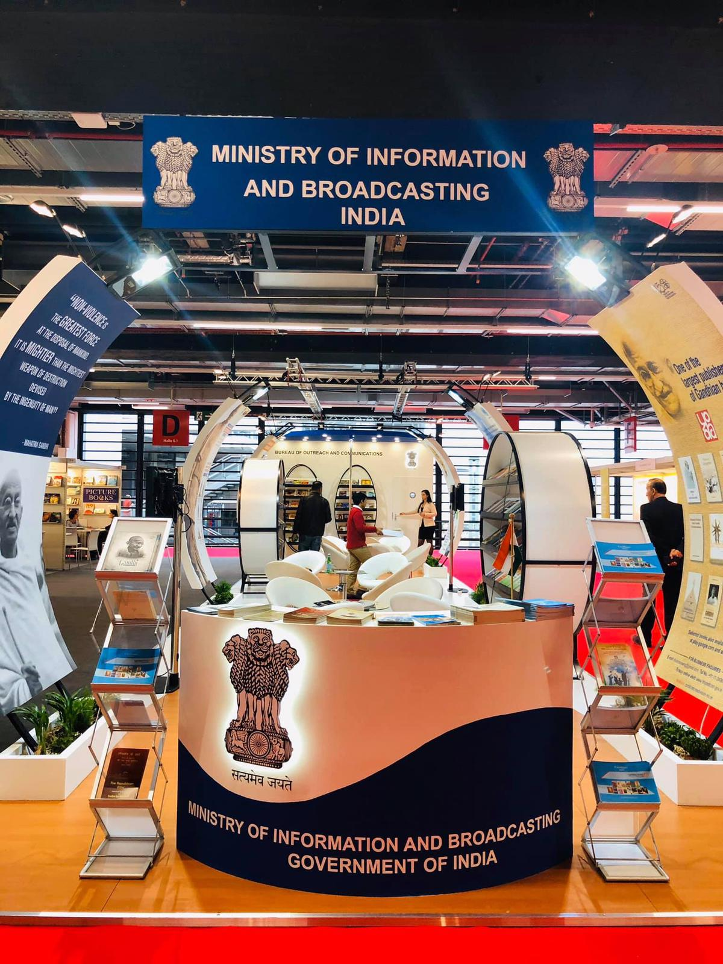

150th Birth Anniversary of Mahatma Gandhi
- Commemorating the 150th Birth Anniversary of Mahatma Gandhi, Bureau of Outreach & Communication (BOC) organized series of Interactive Digital Exhibitions across the country from 2nd October, 2019 onwards.

- Three Large Scale Interactive Digital Exhibitions were organized at Delhi, Guwahati and Rajkot.

- Delhi, 2nd October: Minister of Information & Broadcasting and Forest, Environment & Climate Change, Prakash Javadekar inaugurated the exhibition “Swachh Bharat, Sashakt Bharat-Bapu Ke Sapno Ka Bharat” on 2nd October at India Gate, Delhi. Minister of Petroleum and Natural Gas and Minister of Steel, Dharmendra Pradhan and Minister of Tourism Shri Prahlad Singh Patel were also present on this occasion. The five days exhibition concluded on October 6th, 2019.

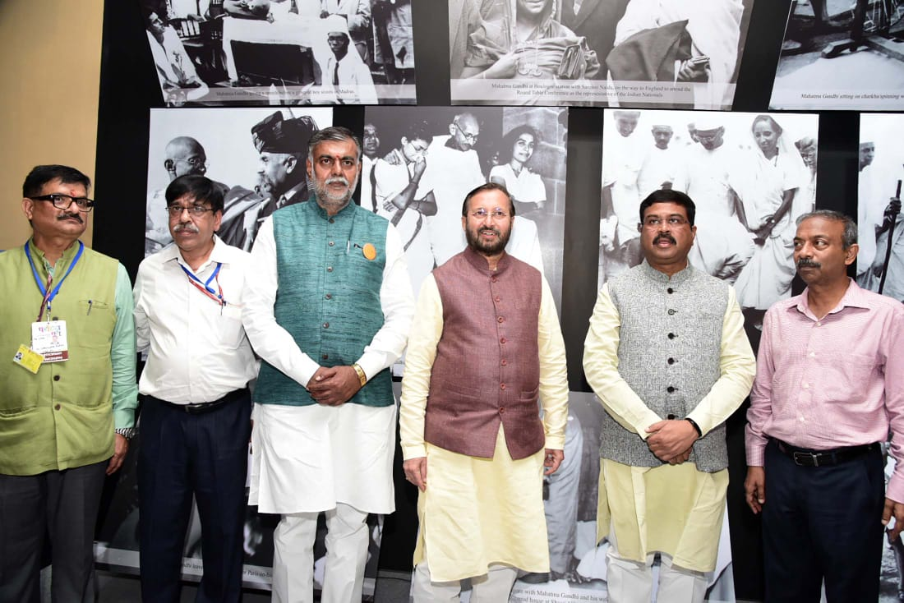

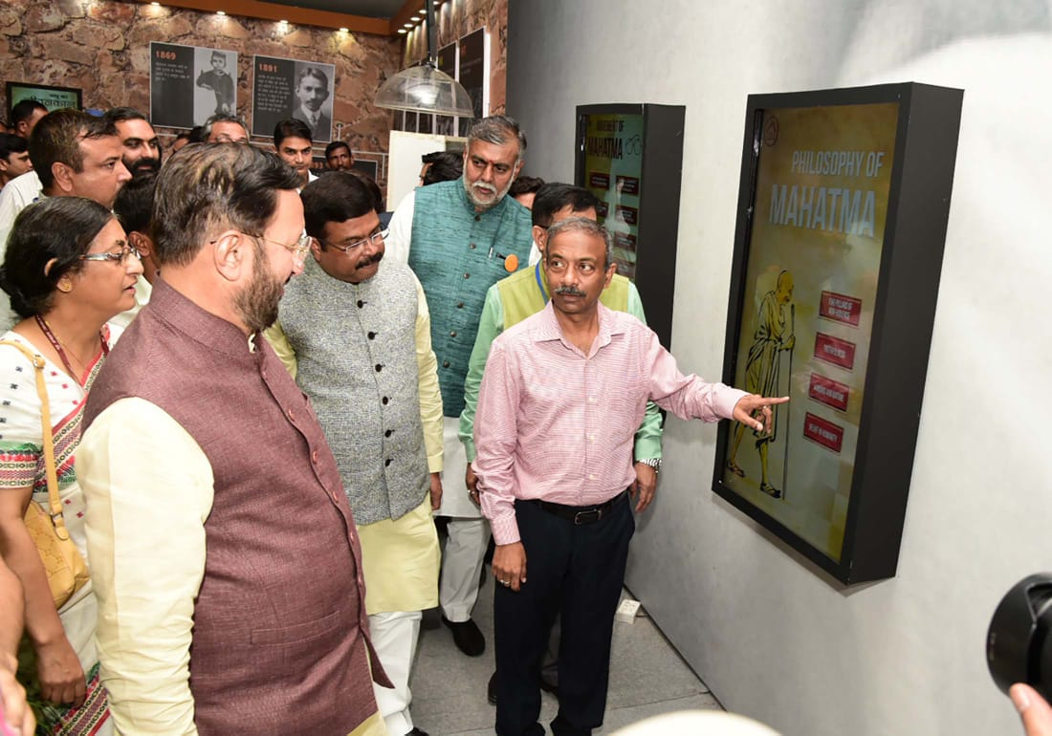

- With the help of technology driven tools, the exhibition showcased the life of Bapu through interactive display boards and screens. In addition, through some of the innovative tools like Augmented Reality, Virtual Reality, 3-D Holograms and Simulations etc. the experience of the exhibition was enriching for the visitors. The exhibition also encompassed a model of ‘Swachh Gram’ based on the ideology of Bapu on the lines of ‘Bapu Ke Sapnon Ka Bharat’

- Guwahati: A seven-day Mega Interactive Digital Exhibition on 150th Birth Anniversary of Mahatma Gandhi was organised at Sonaram High School playground from October 14th, 2019 to October 20th, 2019 by Regional Outreach Bureau, Guwahati under the aegis of Bureau of Outreach & Communication (BOC), Ministry of Information and Broadcasting.

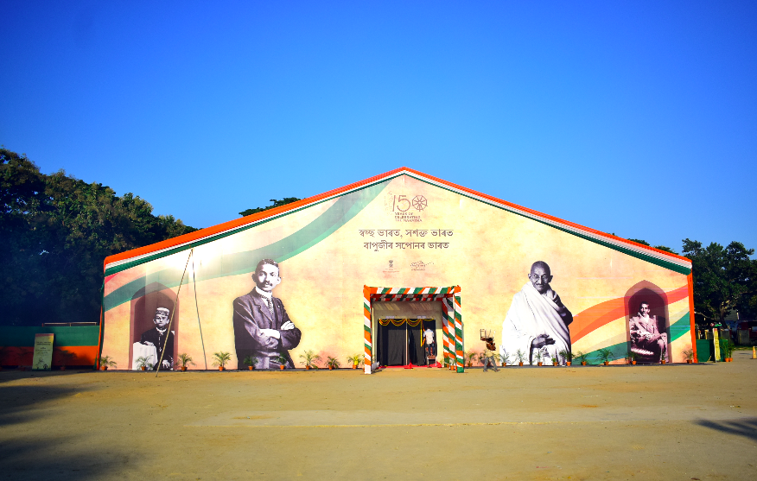

- Hon’ble Governor of Assam, Prof. Jagdish Mukhi, inaugurated the Mega Event on October 14th, 2019. The week long Mega Multimedia Interactive Exhibition was first of its kind in the entire North Eastern region covering an area of 10000sq.ft. The exhibition depicted some of the objects and possession of Mahatma Gandhi along with some rare pictures of Gandhiji’s visit to various places in Assam. In the exhibition, the handwritten letters of Gandhiji, rare pictures of his life and stay in South Africa, flip book, a complete timeline of Mahatma Gandhi were also showcased.

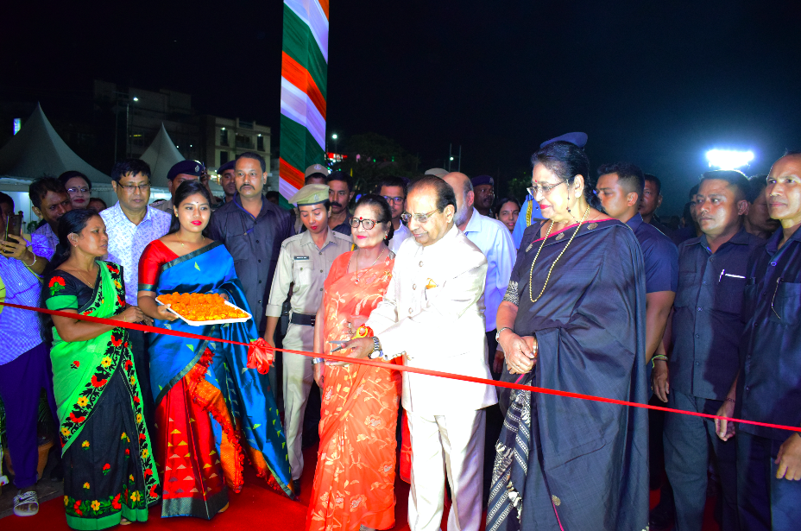

- Rajkot: The Regional Outreach Bureau (ROB) Ahmedabad under the aegis of Bureau of Outreach & Communication (BOC), Ministry of Information and Broadcasting organised seven-days Multimedia Exhibition on 150th birth anniversary of Mahatma Gandhi in Rajkot, Gujarat from October 12, 2019 till October 18, 2019.

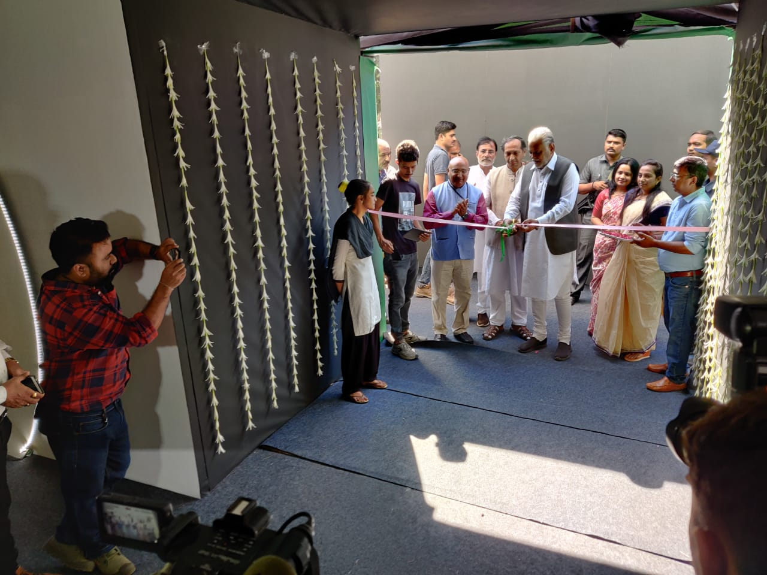

- Rajkot preserves the childhood memories of Bapu where he studied and grew up. Also, the famous Satyagrah movement by the Father of The Nation was initiated from this place.

- The ROB organized the exhibition using multimedia tools. Students, researchers and academicians from across the region participated in the exhibition. In addition, discussions, interactive sessions and other programmes were also organized during a week’s celebrations.

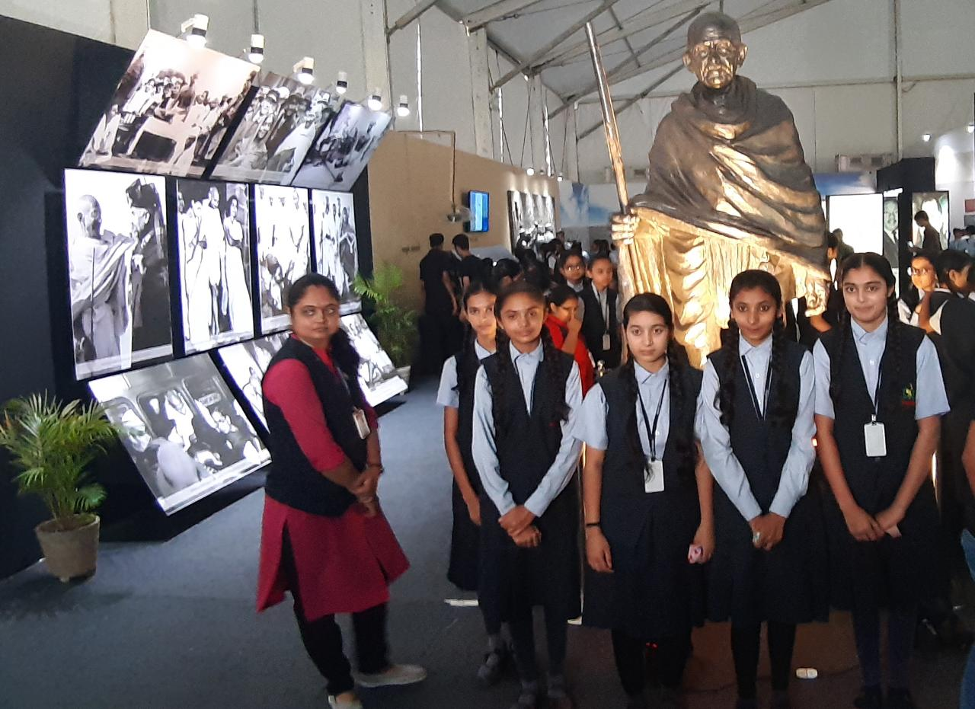

- An advertisement was issued on 2nd October, 2019 (half page) on the eve of Birth Anniversary of Mahatma Gandhi.

- Sixteen Medium Scale Interactive Digital Exhibitions on Bapu were organized in the month of October and November, 2019 at Karimnagar, Katra, Porbander, Chandigarh, Vijayawada, Madurai, Manipal, Muzaffarpur, Siliguri, Gorakhpur, Haridwar, Bokaro, Cuttack, Sagar, Raipur and Udaipur. The glimpses of the exhibition are as under:

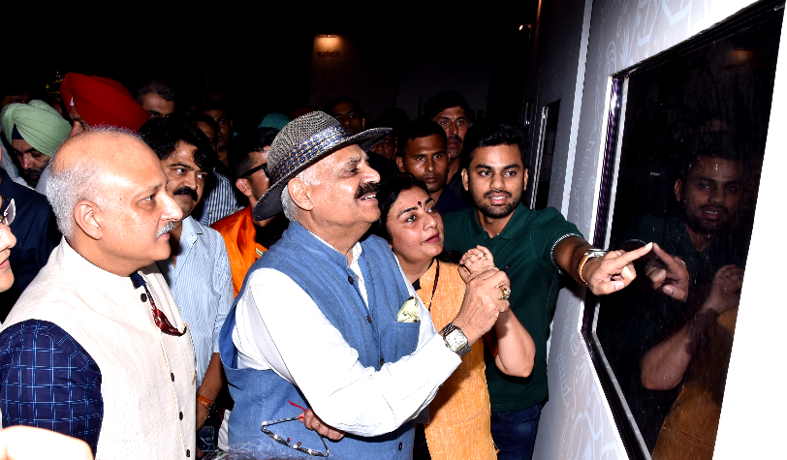
Exhibition at Chandigarh, inaugurated by VP Singh Badnore, Governor, Punjab

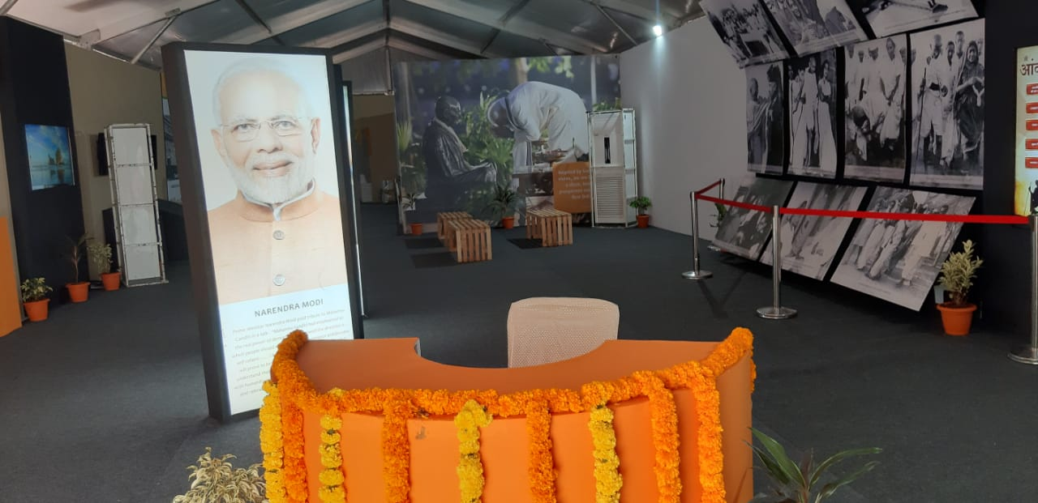
A view of the exhibition at Karimnagar

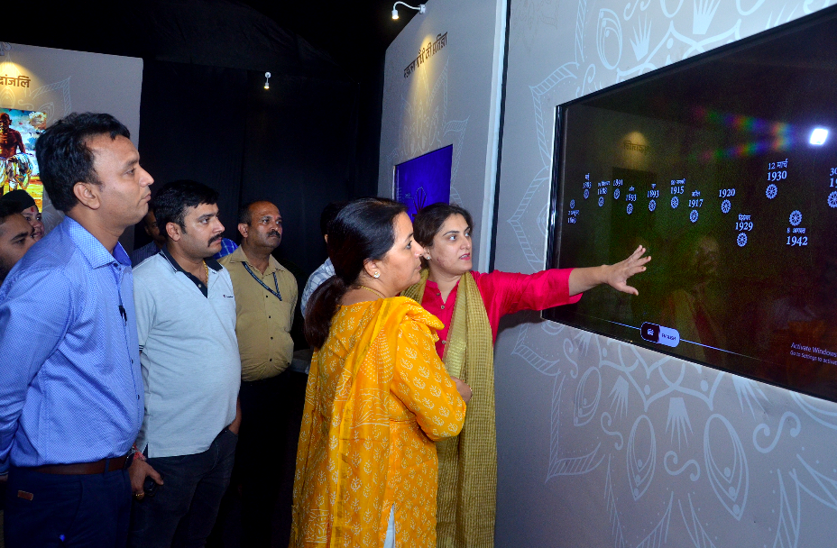
Visitors were taken through the life history of Mahatma Gandhi with the help of digital screens (Exhibition at Katra Vaishno Devi)

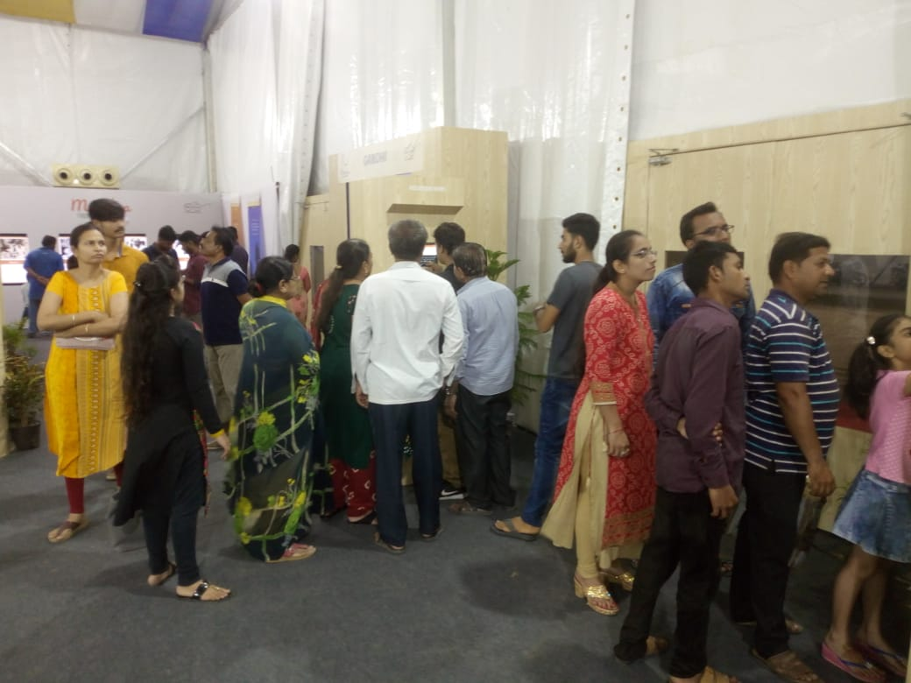
Exhibition at Porbandar

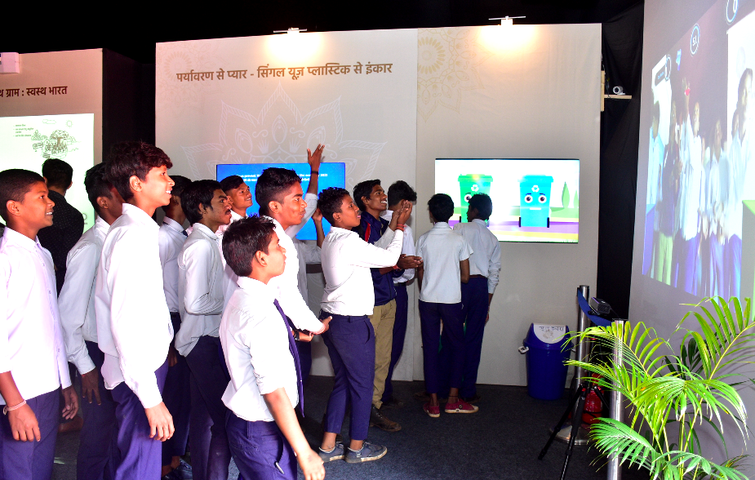
Students enjoying Augmented Reality (AR), Raipur

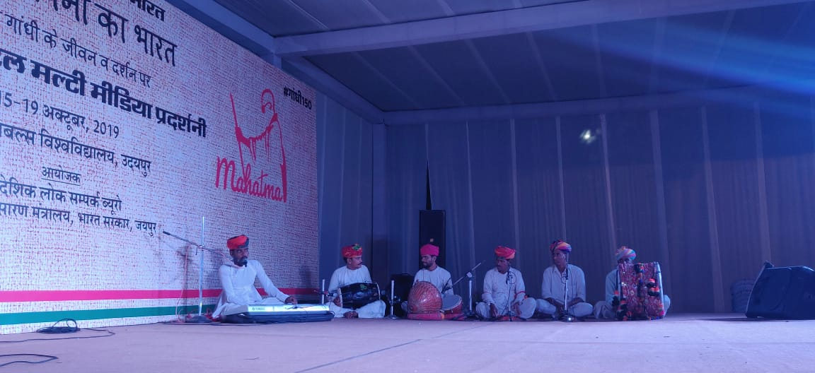
Cultural programme organized during the exhibition at Udaipur

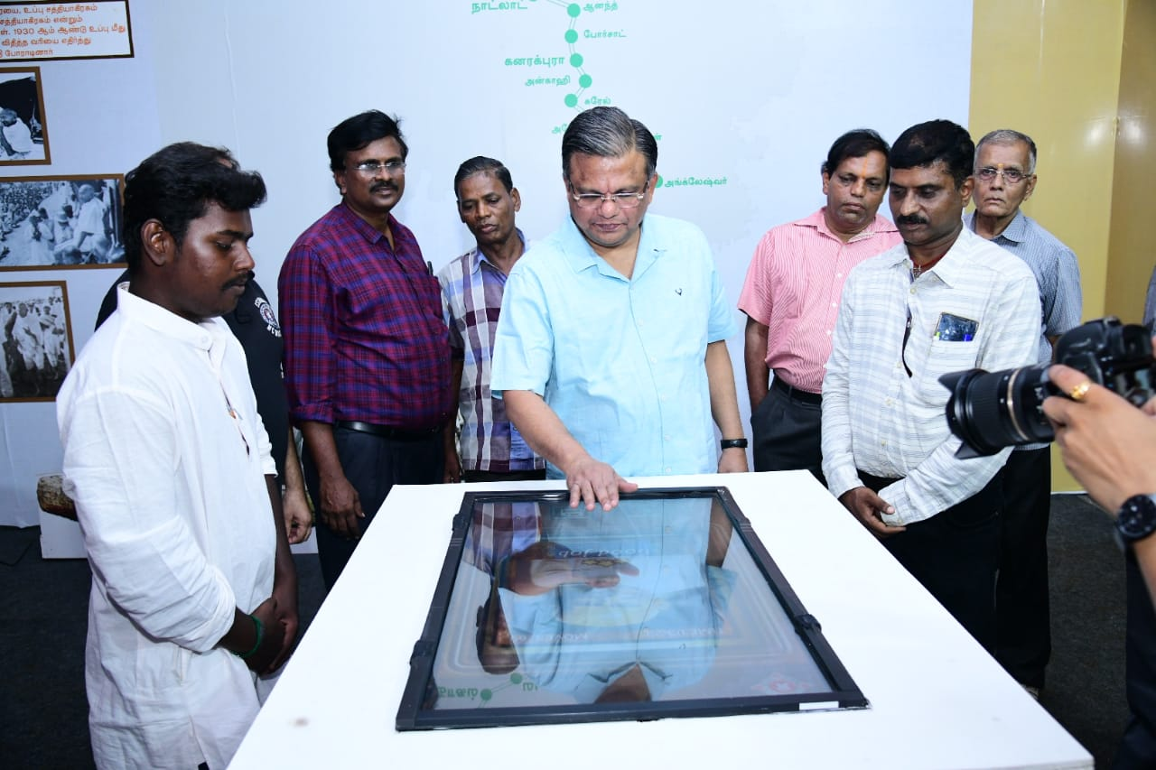
Hon’ble Judge of Madurai Court enjoying digital jigsaw puzzle

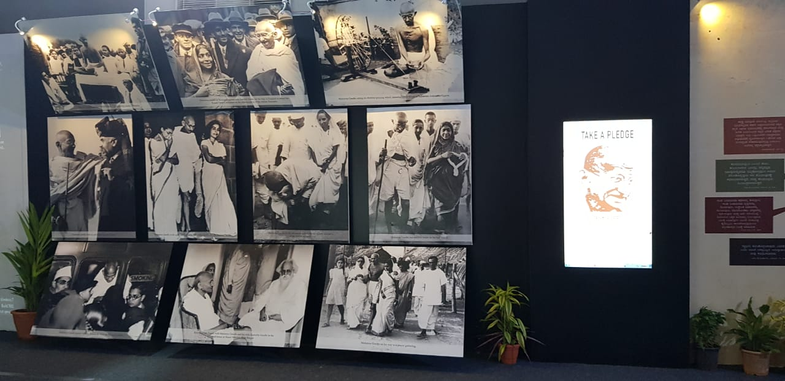
A view of the exhibition in Manipal

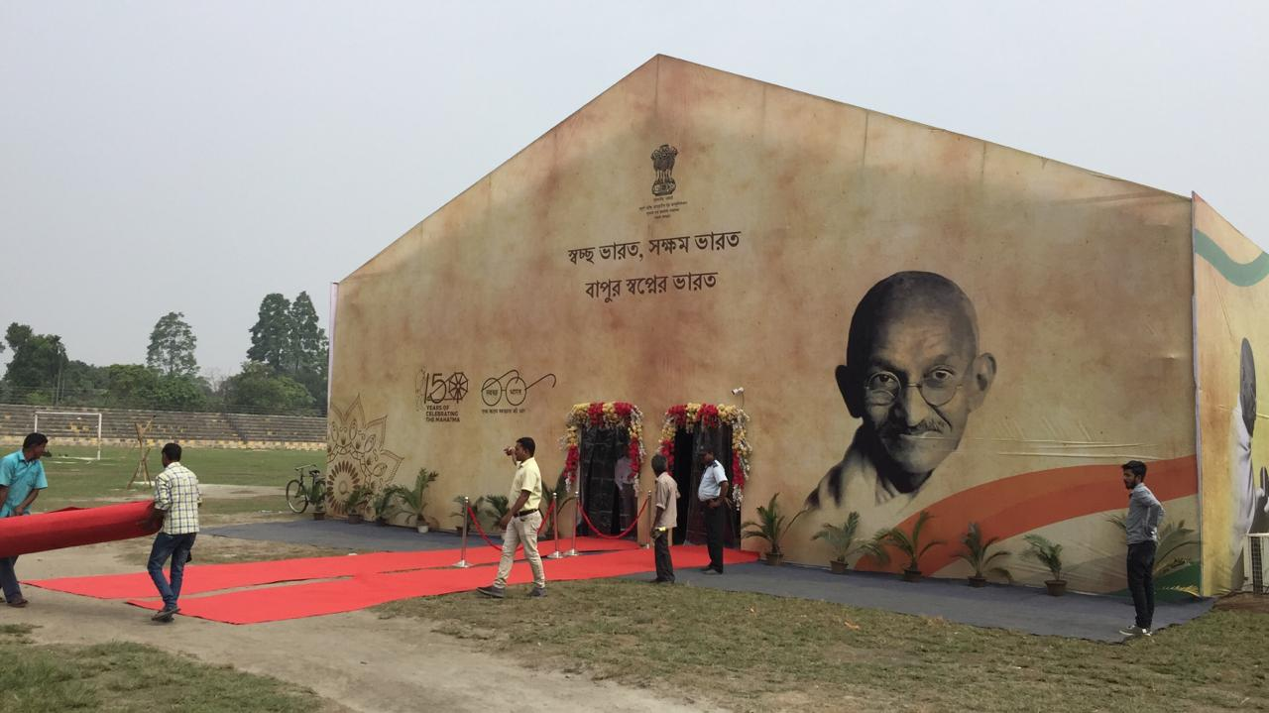
A view of the exhibition in Siliguri

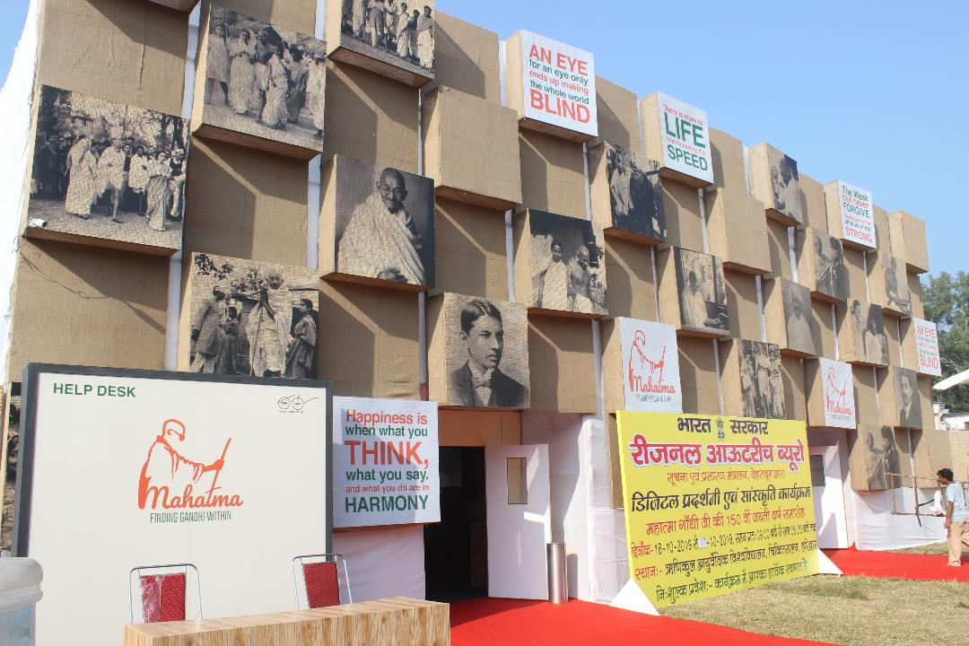
The view of the exhibition at Haridwar

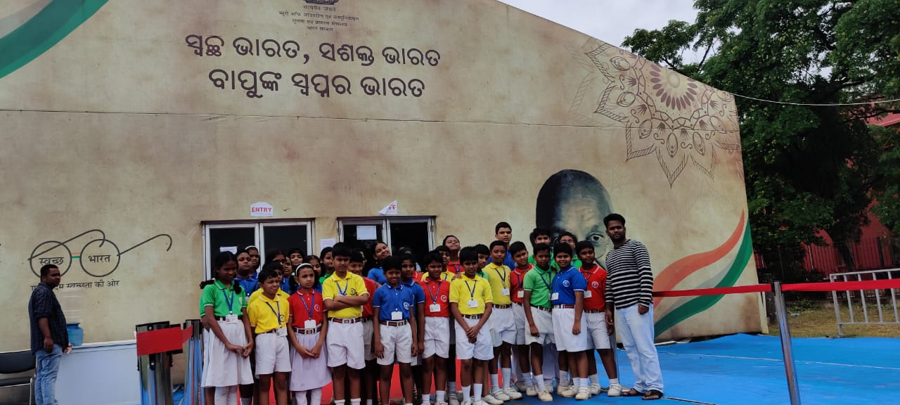
Young students visited the exhibition in Cuttack

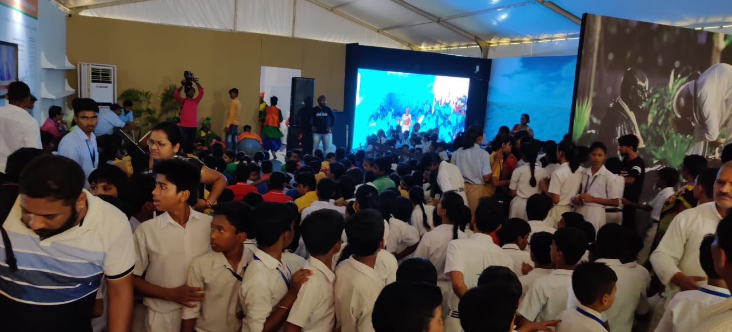
Students enjoying the AR at the exhibition in Bokaro

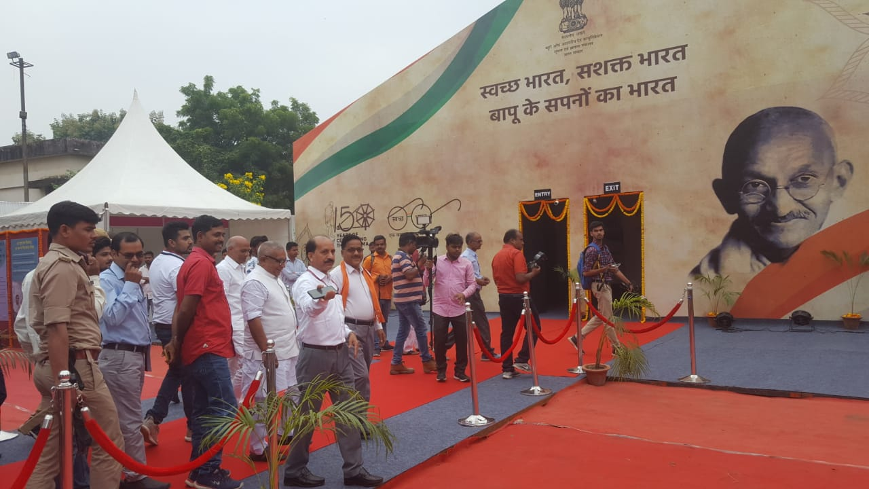
Guests and visitors taking a look around the exhibition at Gorakhpur

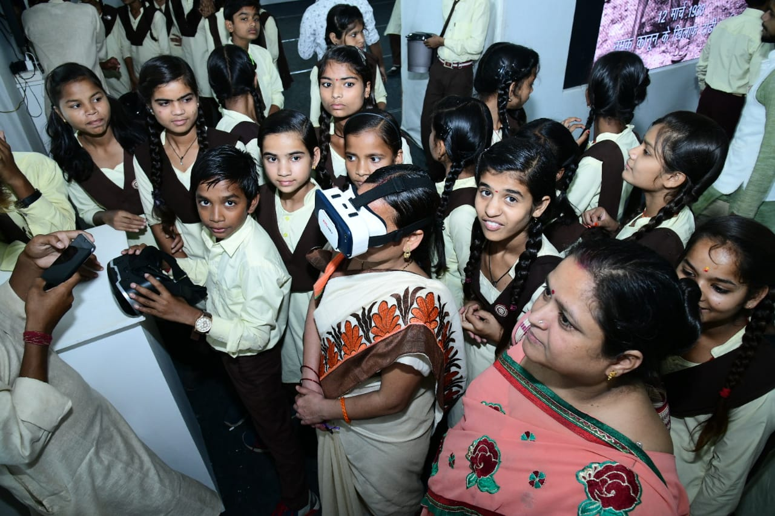
Teachers and students enjoying VR experience during the exhibition at Sagar

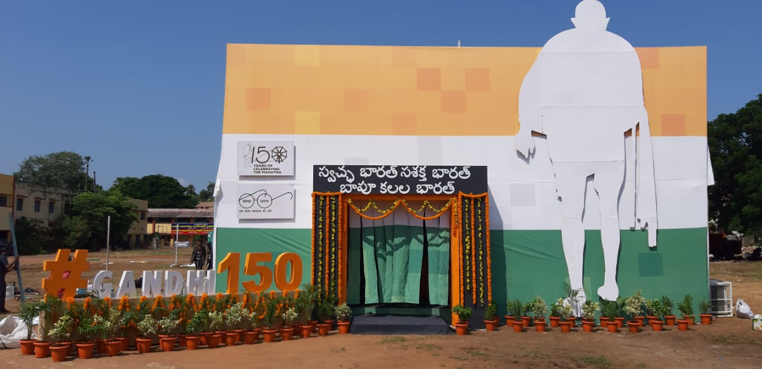
A view of the exhibition from the outside in Vijayawada

Nagaland
- Chief Minister of Nagaland, Neiphiu Rio inaugurated the Digital Interactive Exhibition organized by Bureau of Outreach and Communication commemorating the 150th Birth Anniversary of Mahatma Gandhi at the Hornbill Festival in Kisama near Kohima, Nagaland from December 1st to December 10th. The 10-day event was organised for the first time ever by Ministry of Information and Broadcasting at the Nagaland's annual Hornbill festival. Bureau of Outreach & Communication, organized the exhibition to present Gandhian values and principles to the people and through the people in a contemporary idiom.
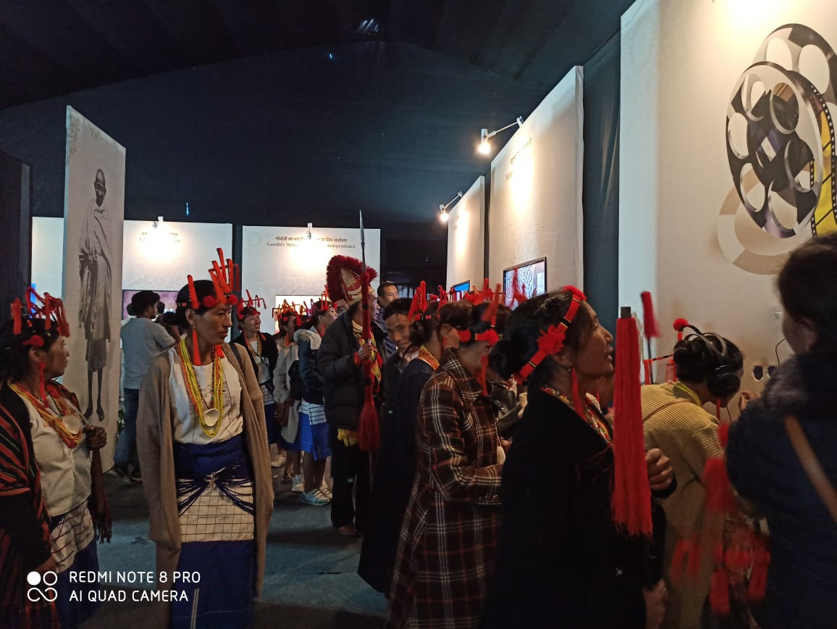

Itanagar
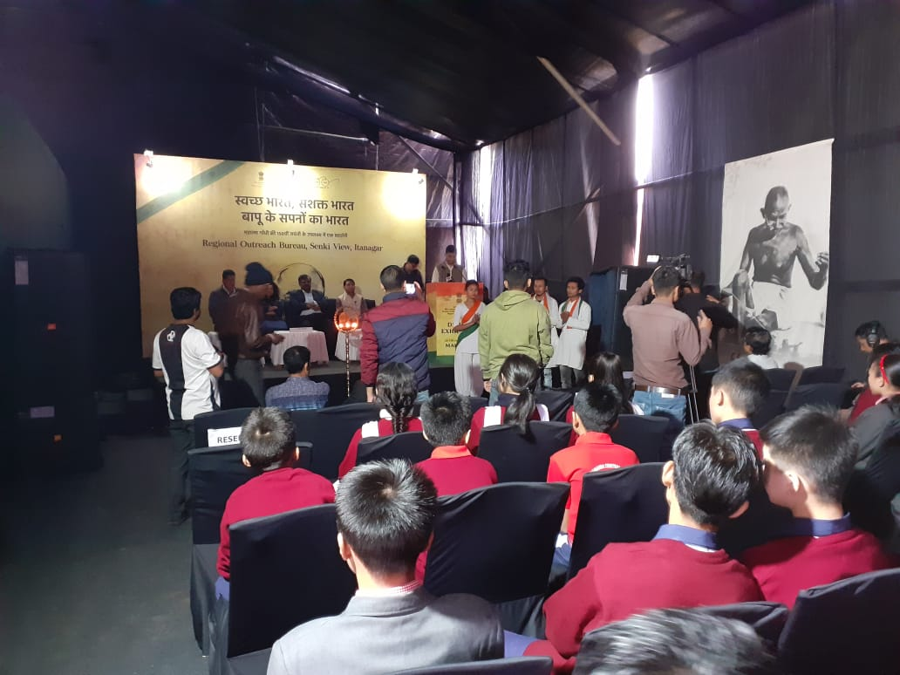
Digital Interactive Exhibition on the life and philosophy of Mahatma Gandhi
Wardha
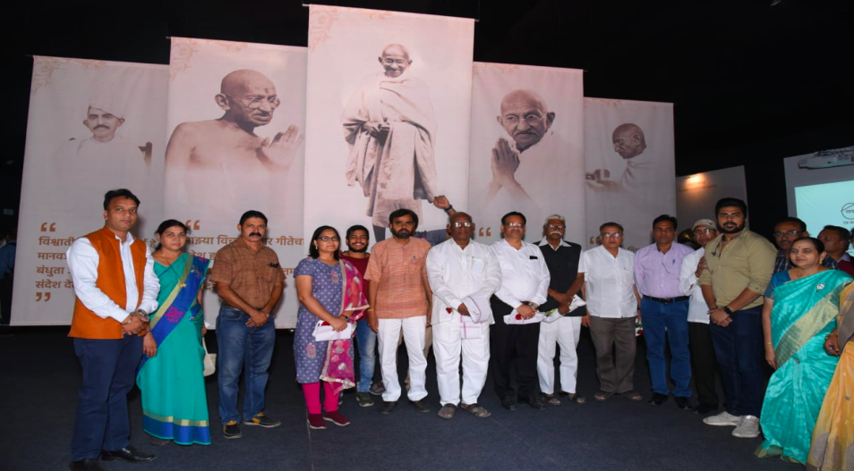
Digital Interactive Exhibition on the life and philosophy of Mahatma Gandhi

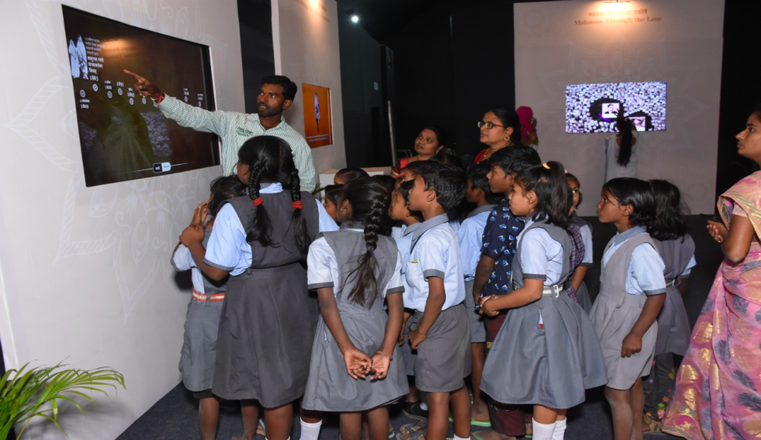
Students visiting at the exhibition

The paradigm shift in communication strategy
Year witnessed paradigm shift in communication strategy i.e. from isolated scheme/Ministry centric advertisements to theme based low cost communication campaigns resulting in adoption of holistic approach for common branding for the Government of India, more synergy and lesser redundancy in outreach and optimum utilization of resources.
ADVANTAGES
- Common Branding for GOI
The present communication strategy projects welfare measures as separate standalone entities. With Thematic Integration of campaigns, Government interventions appears more comprehensive and holistic. Government thereby is projected as a cohesive entity.
- Holistic approach for a better impact
Government interventions when communicated in a holistic manner tend to be comprehended better by beneficiaries and therefore, enable better utilization. This enhanced the understanding of beneficiaries towards the schemes and programmes. Further, thematic campaigns, by presenting interventions as comprehensive solutions and resulted in a more effective connect with people.
- More synergy, lesser redundancy in campaigns and outreach
At present, there is often duplication of messaging. Thematic campaigns enabled entities that have been following separate strategies to converge and form a common communication strategy.
- Optimum utilization of resources
The present approach to communication and outreach proceeds in silos. This in turn often leads to inefficient deployment of resources. With thematic campaigns, better planning done through concerted efforts which resulted in optimum utilization of resources.
- Better monitoring and supervision of campaigns
Thematic campaign makes it easier to track and evaluate the effectiveness of the strategies employed. This also enables easier course corrections and modifications, if found necessary.
550th Birth Anniversary of Sri Guru Nanak Dev Ji
Digital Interactive Exhibitions & Sound & Light:

- 12th November, 2019 marks the 550th birth anniversary of Sri Guru Nanak Dev Ji. On the occasion of the 550th Birth Anniversary of Guru Nanak Dev Ji, Bureau of Outreach and Communication (BOC) successfully organised a Sound & Light Show. Interactive Digital Exhibitions were also organised across the country. The goal was to convey his teachings, morals and the way of his life to our youth and the people of our country irrespective of social status, gender, cast and religion, so that they can be a part of this grand celebration through interactive digital content, displays, AVs, projection mapping, VR, and other engaging activities.

Exhibition at Sultanpur Lodhi
- Highlighting the three prime teachings of Guru Nanak Dev Ji, ‘Kirat Karo, Naam Japo, Vand Chakko’ in a 3D revolving theatre had become the centre of attraction in Sultanpur Lodhi. Various illustrations related to the Sikh Guru’s life had been displayed at the exhibition using technologies such as Augmented Reality and Virtual Reality, hologram and 3D picturisation.

- Giving a live experience of the Langar Sewa using technology, two ‘VR Langer’ play stations had been installed in the exhibition, which gave 3D exposure of the ‘Langar sewa to visitors. The exhibition was inaugurated by Shri Prakash Javadekar, Minister of Environment, Forest and Climate Change and Minister of Information and Broadcasting in the gracious presence of Smt. Harsimrat Kaur Badal, Minister of Food Processing Industries.
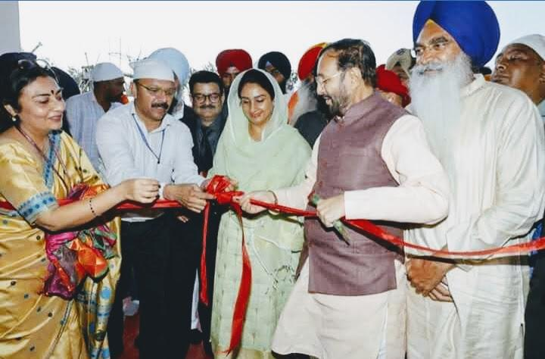

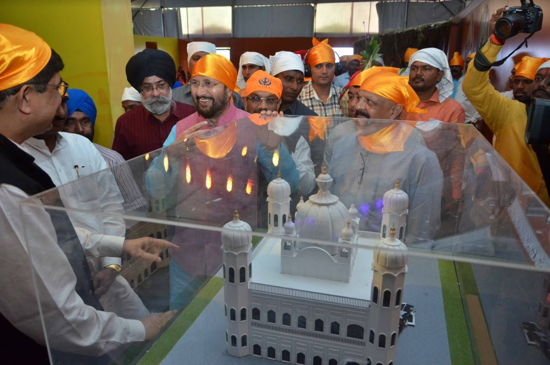

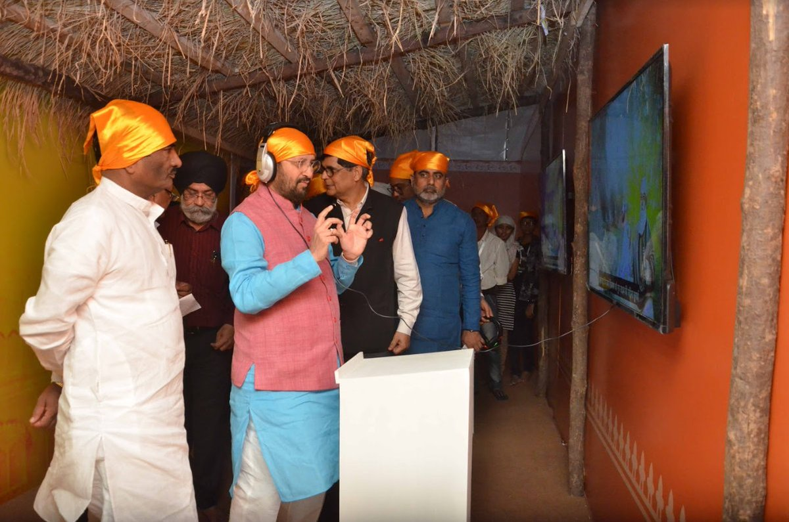

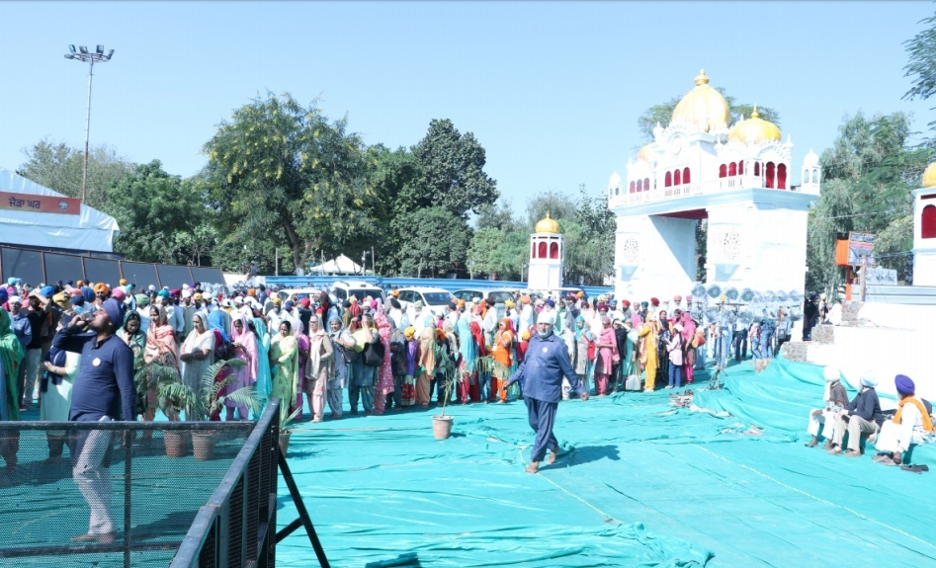

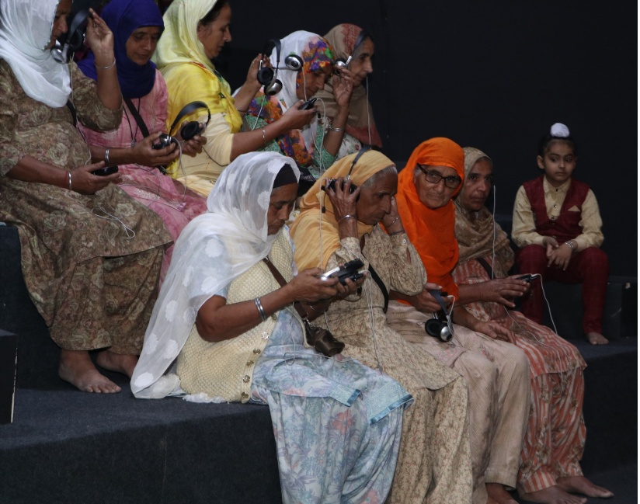
- The 7 multi-media exhibitions categorized into large-scale and small-scale exhibitions were also organized. Large-scale exhibitions took place in Patna and Nanded whereas small-scale exhibitions were organized in Kullu (Himachal Pradesh), Jammu (J&K), Naigaon (Assam) and Varanasi (UP) along with a Sound & Light Show in Amritsar highlighting his life stories from October to November 2019.

- The whole ambience was created as a replica of ‘Pind Babe Nanak Da' Rai-Bhoi-Di-Talwandi, the village where Guru Nanak was born in 1469 to take people close to his life. A thematic kitchen area was set up with a screen, playing AV made on the popular ‘Shabad’ on Shri Guru Nanak Dev ji along with some clay pots to add to the village ambience.

- A rotating ‘Ek Onkar’ covered with acrylic box, was installed to give the ambience a dynamic look. A life size wooden finished Digital Tree with hanging in-lit boxes, displaying different Sakhiyan of Shri Nanak Dev ji which also became a selfie point. Large LED screens showcased the Birth, Youth, and Life Journey of Shri Guru Nanak Dev ji through audio-visual in Punjabi along with Hindi subtitles.

- A quarter page colour advertisement was issued in dailies on 12th November towards the commemoration of 550th Birth Anniversary of Sri Guru Nanak Dev Ji.

- A half page colour advertisement was released on the opening of Kartarpur Corridor detailing the initiatives of Government of India to facilitate pilgrimage to Kartarpur.

IFFI@50: Glamorous advent of Golden jubilee of IFFI 2019
- On the occasion of golden jubilee of IFFI2019, Bureau of Outreach and Communication (Regional Outreach Bureau, Pune) in association with the National Film Archive of India, organized an interactive digital exhibition ‘IFFI@50’. The exhibition was inaugurated by Secretary, Ministry of Information and Broadcasting Shri Amit Khare.

- The exhibition covered a total of 20,000 sq. ft. of the space at Darya Sangam, Near Kala Academy, Panaji Goa, tracing back the beautiful journey of International Film Festival of India since 1952 edition. Merriments of the exhibition continued for 8 days from 21st November till 28th November 2019.

- BOC printed 3 books, ‘Catalogue on International cinema for 50th IFFI’, ‘Catalogue on Indian Cinema for 50th IFFI’, ‘ IFFI handbook’, on the occasion of 50th edition of IFFI.

Run for Unity & Birth Anniversary of Sardar Vallabhbhai Patel:
- Nation celebrated Birth Anniversary of Sardar Vallabh Bhai Patel as National Unity Day (Ekta Diwas) on 31st October, 2019. Run for Unity campaign was organized across the country. To create awareness among the masses and to ensure maximum participation Print, Audio Visual and Outdoor Publicity advertisements were released.
- Advertisement on the theme “Run for Unity- अब दौड़ेगा इंडिया लक्ष्य की ओर” was designed by BOC. The advertisement was released in various newspapers on 29th October, 2019.
- Advertisement on the theme “राष्ट्रीय एकता दिवस- आइये मनाते हैं भारत की एकता का पर्व in Hindi and “National Unity Day- let us celebrate the festival of India’s Unity” in English was designed by BOC and advertisement was released in various newspapers on 30th October, 2019.

Historic Decision by Modi Government
- Historic Decision by Modi Government for Unauthorized Colonies in Delhi: Print Advertisement were designed and released in various newspapers from Delhi on the decision taken by Government to regularize unauthorized colonies in the National Capital. The theme for the advertisement was “मोदी सरकार का अहम फैसला- दिल्ली के अवैध कॉलोनियों मे रहने वाले लोगों को मिला मालिकाना हक़।“

- Booklets on Howdy Modi covering the Howdy Modi event in Houston, USA was designed and printed by BOC.

- Booklet named “Furthering India’s Development: 100 Days of Bold Initiatives & Decisive Actions “ in English and ‘ ऐतिहासिकजनादेश का सम्मान : कठोर परिश्रम और बड़े निर्णयों के 100 दिन “ in Hindi was designed printed and distributed by BOC. The booklet was released by Hon’ble Minister of I&B on 7th September, 2019 in a Press Conference.

- E-versions of the booklet was also released and disseminated through mygov.in, Ministry of I&B’s website as well as BOC’s website. The booklet was further uploaded on the websites of all the Ministries w.e.f. 9th September, 2019 and remained there as landing page for 2 days.

- Regional Outreach Bureaus also organized exhibitions on completion of 100 days of Modi Government highlighting major achievements.

- BOC prepared, designed, printed and distributed a booklet “Jan Connect” on 75 days of Modi 2.0 government. The booklet titled “Clear Intentions, Decisive Actions” highlighting its achievements was released by Information & Broadcasting and Environment, Forest and Climate Change Minister Shri Prakash Javadekar on 28th August, 2019 at a function in New Delhi.

- A booklet on 50 days of Modi Government “Fifty days of Modi Government: Decisive & Directional” was designed and printed by Bureau of Outreach & Communications.

- The booklet concentrated on Budget 2019, Foundation for $ 5 Trillion Economy, Marching Ahead from Day One, Promises Delivered, Modi Government’s Work Wins Global Praise, India Leading The Global Narrative and PM Modi at the G20- Wide Outreach, Futuristic Outcome. Copies of the booklet were printed in English & Hindi each for distribution to the Member of Parliaments, Journalists and Opinion Makers.

- A separate booklet was also printed titled “5 Trillion Dollar Economy: The Target” spelling out the master plan of growth for 5 years.

Jalshakti Abhiyan

- On the occasion of beginning of swachata fortnight Hon’ble Union Minister of Information and Broadcasting Shri Prakash Javdekar flagged off a mobile exhibition mounted on a Bus specially designed and branded as 'Jaldoot' to spread awareness about the need for water conservation on 14th September, 2019 from Pune. The Exhibition on wheel travelled 8 identified districts and 27 Urban Local Bodies across Maharashtra during one month campaign. He also administered swachhata oath to the participants. HMIB also visited exhibition put up on Furthering India’s Development: 100 Days of Bold Initiatives & Decisive Actions at Collectorate Office.

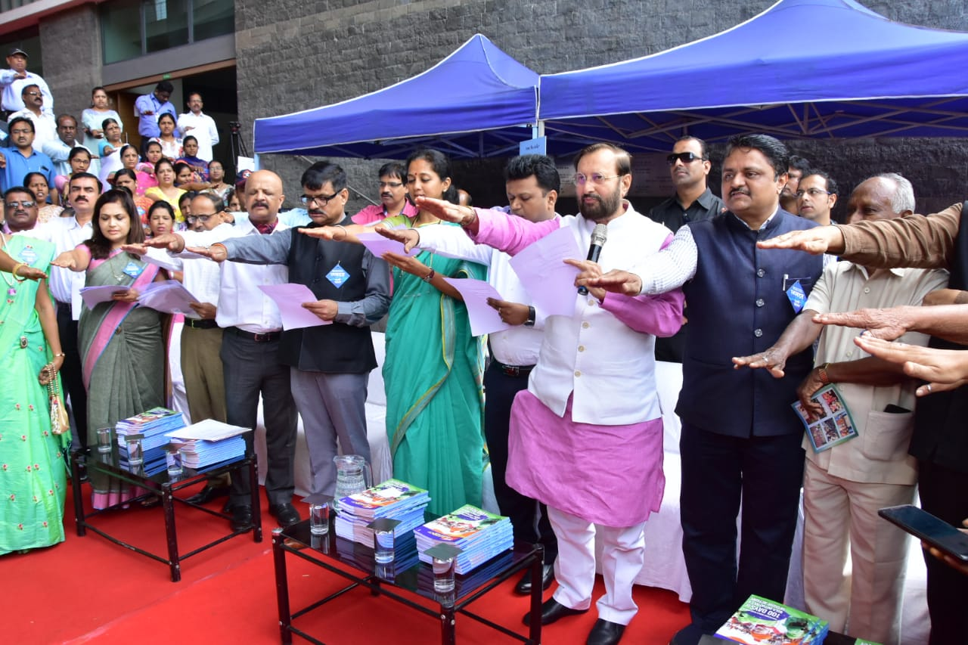

- The exhibition consists of various Information Display Panels and Audio-Visual Components. Song and Drama wing of Bureau of Outreach and Communications cultural troupes and artists travelling along the bus, created awareness about the Government’s Jalshakti Abhiyan initiative.

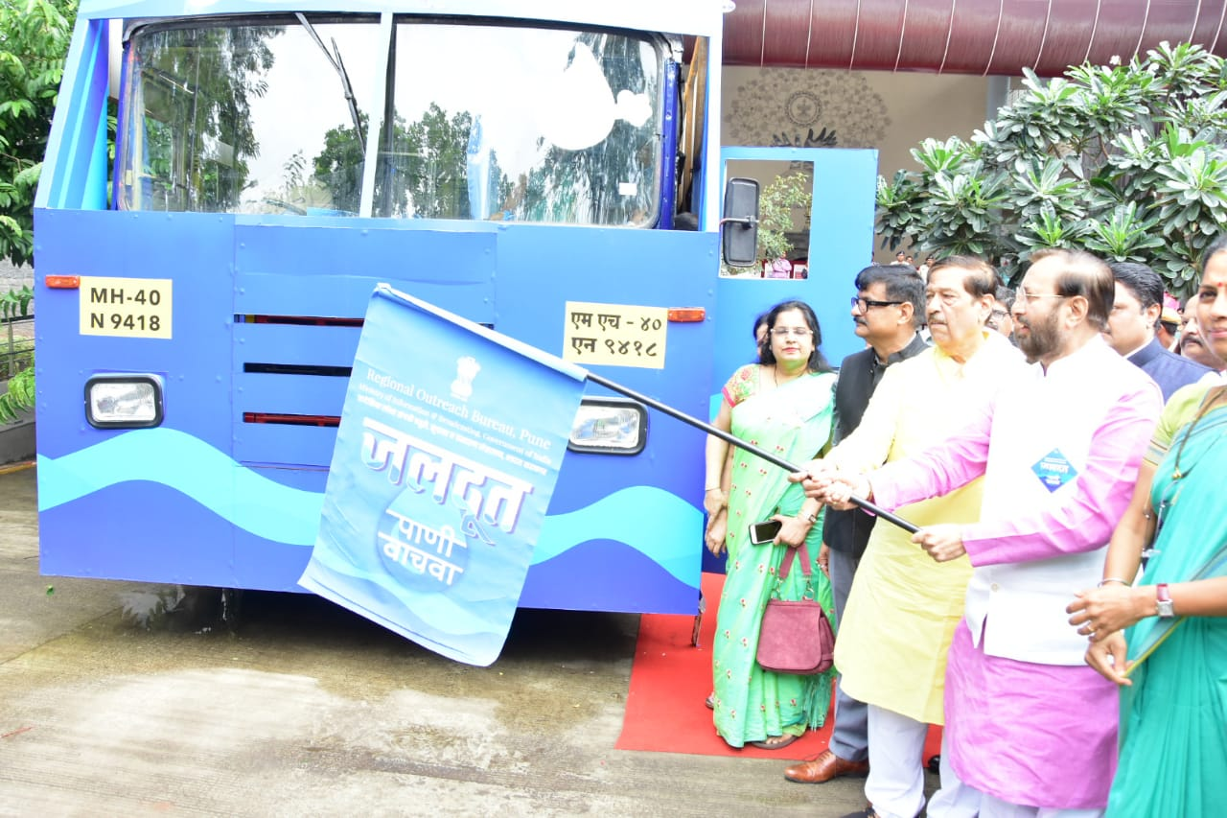

Book on Vice President’s two year in office

- The Bureau of Outreach and Communication published a book on Vice President Shri M. Venkaiah Naidu. The book titled “Listening, Learning & Leading” chronicling the two years in office by Vice President was released by Home Minister Shri Amit Shah on 10th August, 2019 in Chennai at a function organised by Information and Broadcasting Ministry. The Vice-President and the Information and Broadcasting Minister Shri Prakash Javadekar were present on the occasion. The book captures the glimpses of the Vice President’s 330 public engagements across the country in the last two years. The book also showcases the Vice President’s feat as the Rajya Sabha Chairman in enhancing its effectiveness and promoting its efficiency.

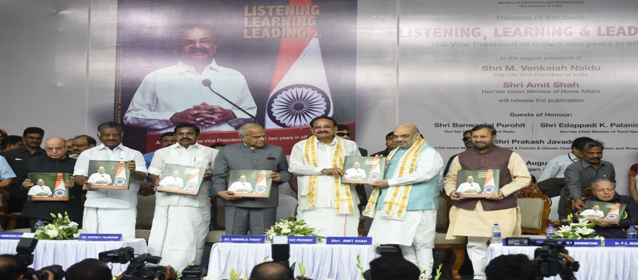

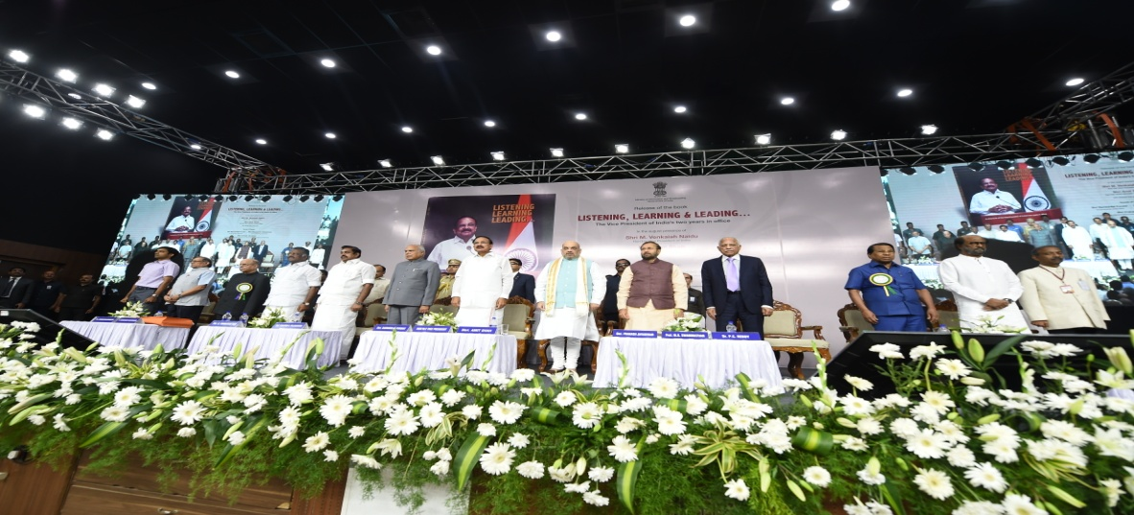

Regional Conference of North-East Zone and Kolkata Region

- A Regional Conference of North-East Zone and Kolkata Region was organized in Guwahati, Assam on 23rd and 24th August, 2019. Shri Amit Khare, Secretary, Ministry of Information & Broadcasting and Shri Vikram Sahay, Joint Secretary, M/o I&B, Shri Satyendra Prakash, DG, BOC, Shri L R Vishwanath DG, North East, and other senior IIS officers in the region including officials of the various departments of Information and Public Relations in the Northeast region states attended the meeting. The conference deliberated on how officers of both the Centre and the State governments can converge and maintain close co-ordination for effective delivery of communication services.

Celebration of International Day of Yoga on 21st June, 2019
- On the occasion of 5th International Day of Yoga Hon’ble Prime Minister Shri Narendra Modi participated in the function organized at Prabhat Tara Maidan, Ranchi. On the sidelines of the Prime Minister’s participation in Yoda Day celebration at Ranchi, Bureau of Outreach and Communication organized 5 day Yoga Exhibition at Vidhan Sabha Ground from 20th to 24th June 2019. The exhibition was inaugurated by the State's Health and Family Welfare Minister Ramchandra Chandravanshi. 5 days digital exhibition on yoga was a point of attraction during entire period for the people of Ranchi. Rush of students and youths was seen for the exhibition. Different programmes and functions were organized on 21st June at Bureau of Outreach and Communication, Headquarter and other Regional Outreach Bureaus also.
- Activities carried out by different ROBs and FOBs is detailed as under:
Number of activities done by ROBs on the occasion of International Day of Yoga
Exhibition | Yoga session | Other activities (Pre-publicity Programmes, Rally, Film Show, Quiz Contest, Painting Competitions, Cultural Programmes, Essay Writing, Seminar, Group Discussion)
272 | 221 | 1692

- In this exhibition, information was given about Yoga through digital mediums. History of Yoga along with the reason behind celebration of Yoga day on 21st June every year and ideology of ​​Prime Minister Shri Narendra Modi was explained through the exhibition. In addition to yoga, details of important schemes of the central government were also given in the exhibition. Along with this, views of Gandhiji and Sardar Vallabh Bhai Patel about yoga were shown through questionnaires.
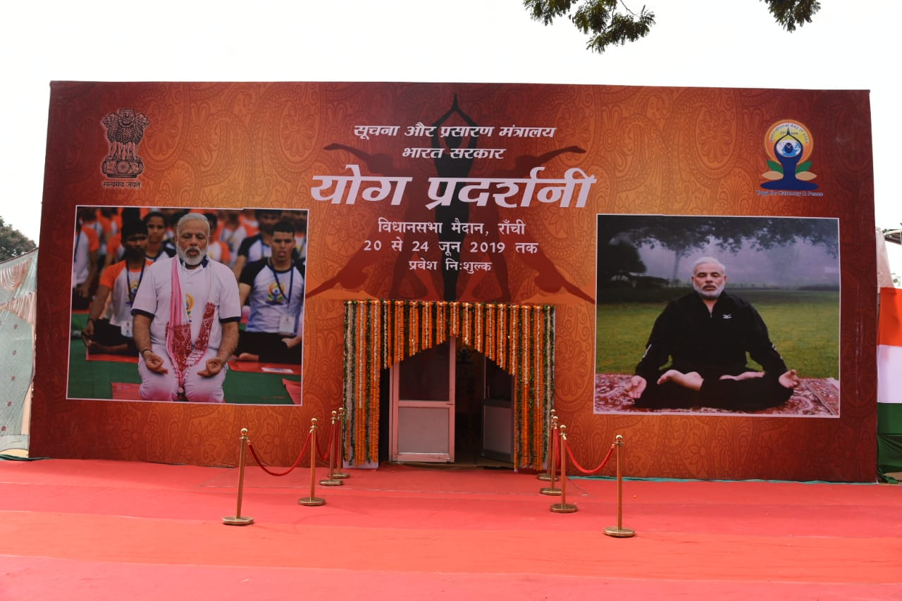
Big facia ofYoga Day exhibition at Vidhan Sabha Ground, Ranchi

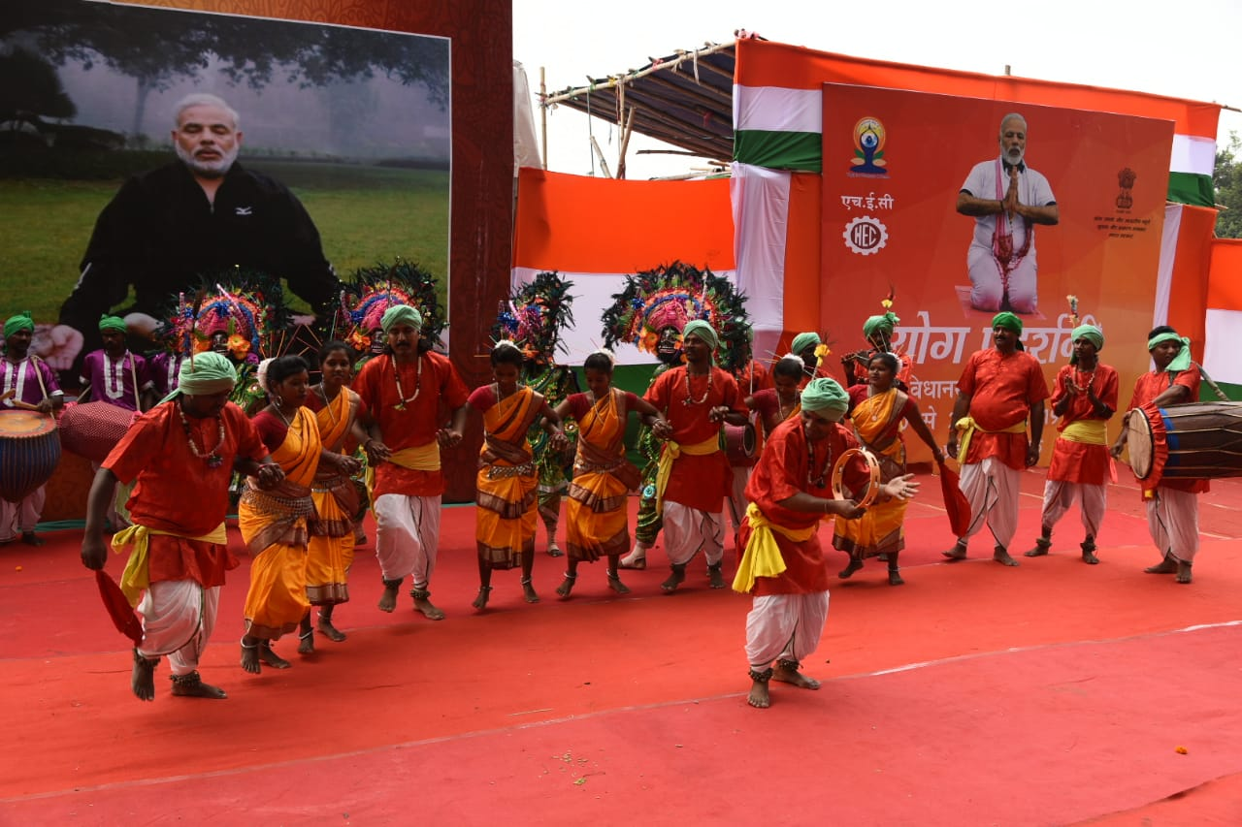
Celebration of International Yoga Day at Ranchi
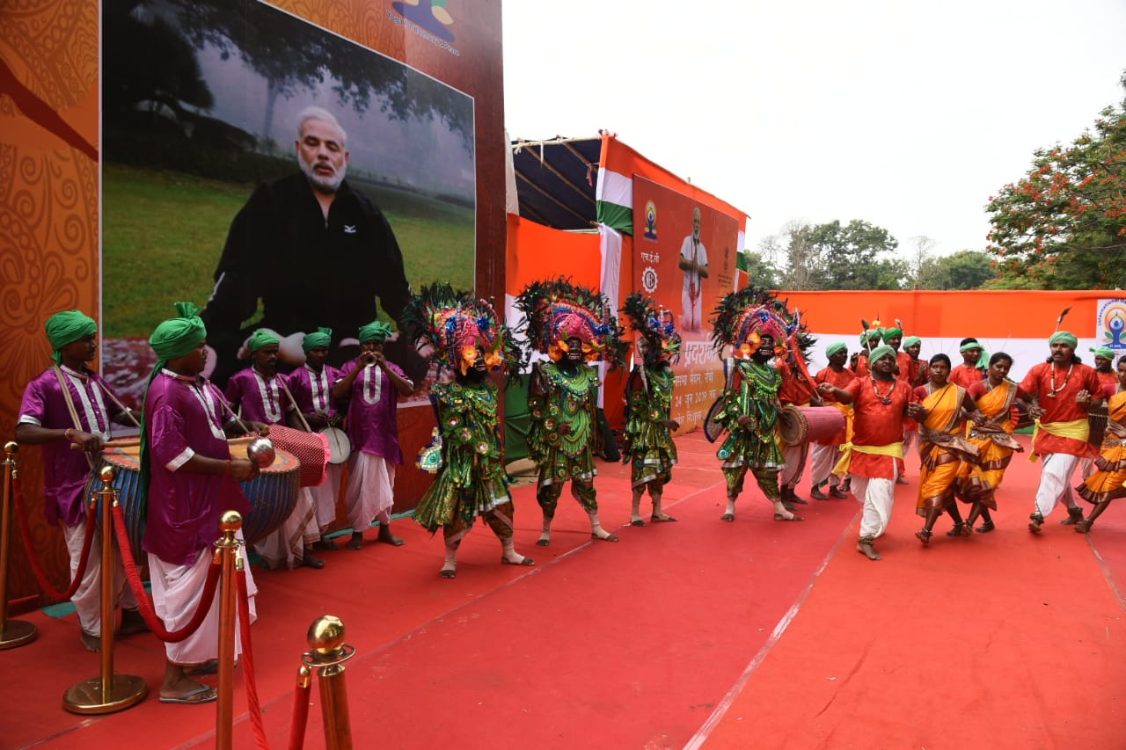
Celebration of International Yoga Day at Ranchi

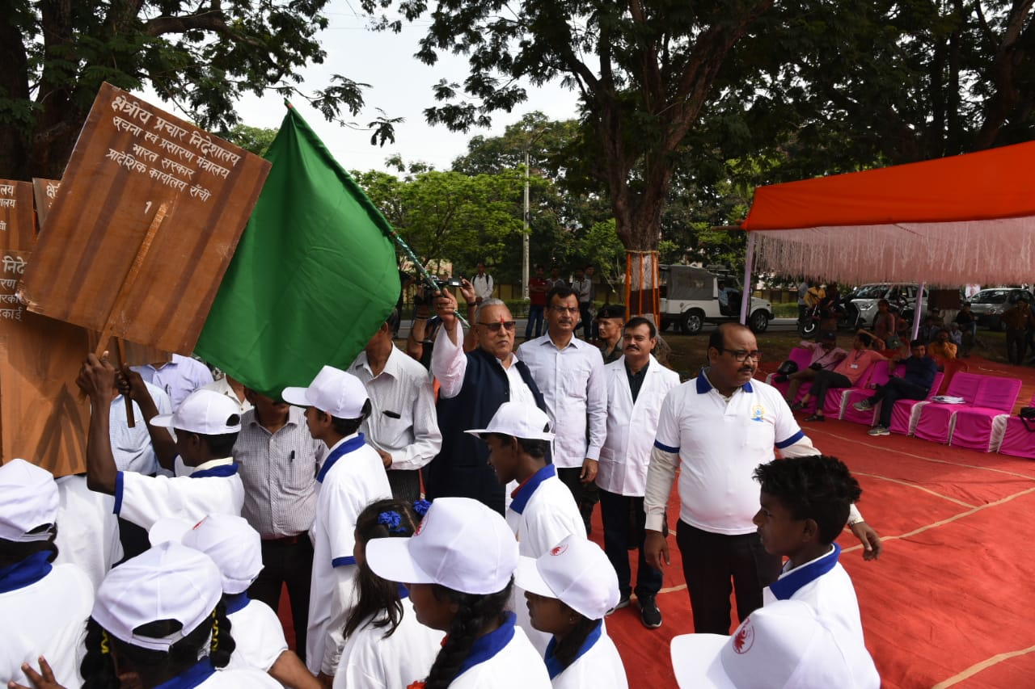
Celebration of International Yoga Day at Ranchi

Yoga at BOC:
- 5th International Day of Yoga was celebrated at BOC Hqrs. and Regional Outreach Bureaus (ROBs) and Field Outreach Bureaus (FOBs) across India. A mass yoga demonstration was held in Soochana Bhavan, BOC headquarters on the occasion of International Yoga Day. All the media organizations located in Soochana Bhavan participated in this event with great enthusiasm. To showcase the importance of making Yoga a part of everyone’s life, an exhibition has also been put up in the premises of Soochana Bhawan. The Yoga sessions were conducted under the guidance of Yoga experts. The event witnessed participation of Shri Satyendra Prakash, DG, BOC, along with other senior officers, other staffs of BOC.
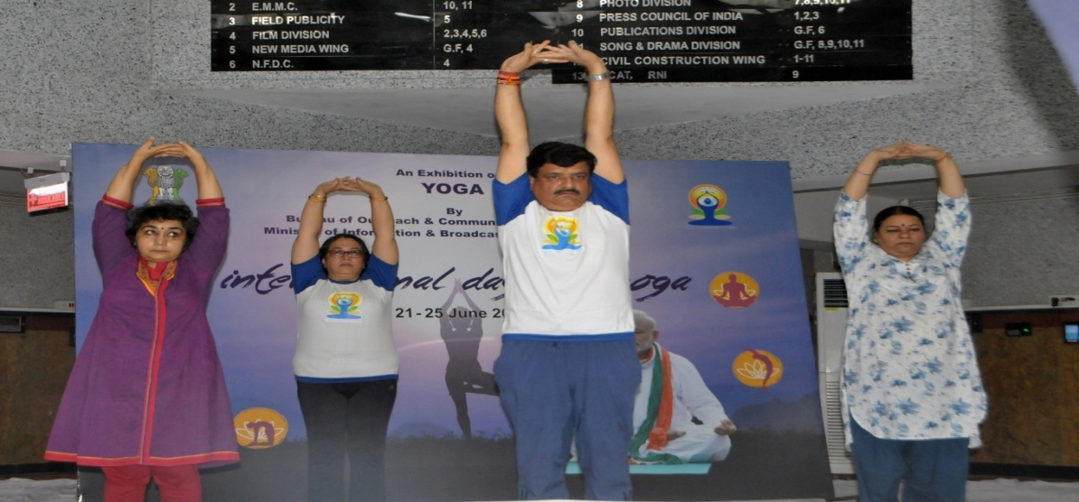
DG: BOC, Practicing Yoga in Soochna Bhavan premises

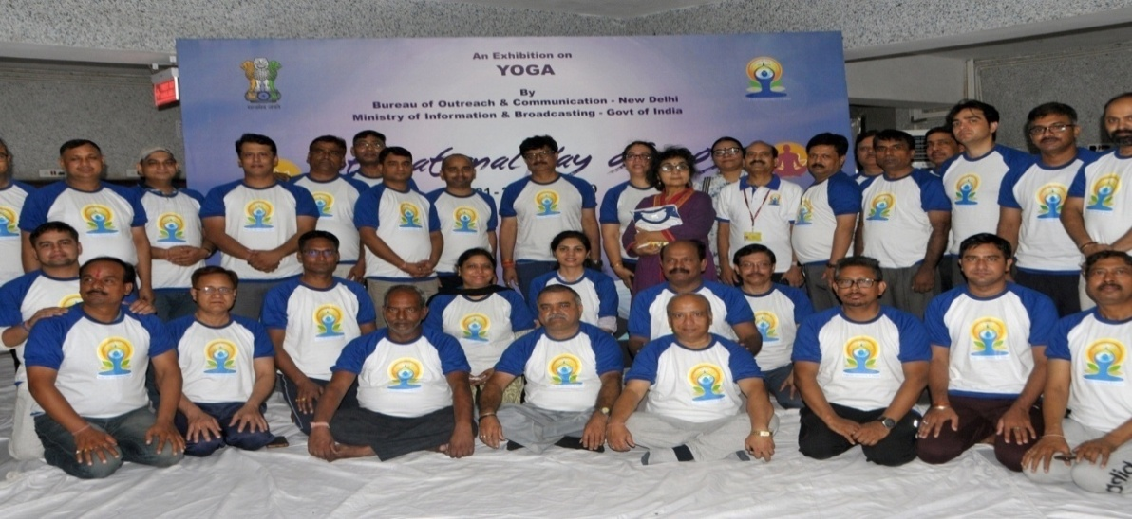
Celebration of 5th International Day of Yoga at Soochna Bhavan

ROB, Chennai:
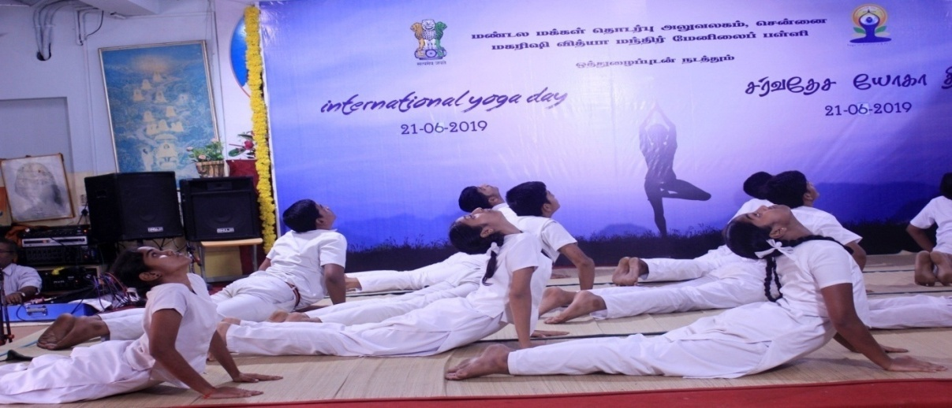
Celebrations of 5th International Day of Yoga 2019 at Ved bhavan Hall of Maharishi Vidya Mandir senior secondary school, Chennai.

ROB, Chandigarh:
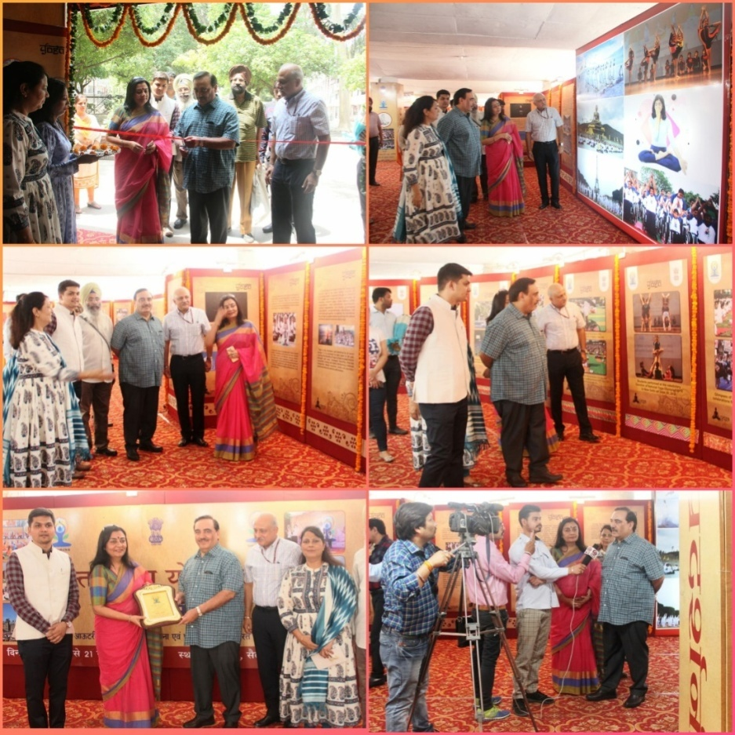
3 days Exhibition inaugurated by Shri Rajeev Arora, Additional Chief Secretary, Health, Haryana on June 19, 2019 at The Plaza, Sector 17, Chandigarh

ROB, Guwahati:
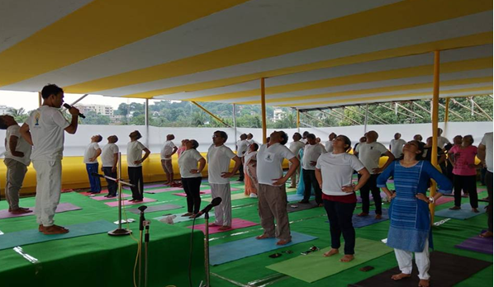
A view of Yoga session at Soochna Bhawan, Chandmari on IDY organised by ROB, Guwahati.
ROB, Shillong:
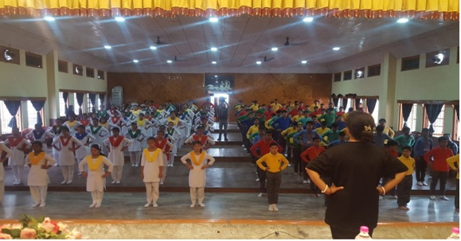
Yoga session at ROB, Shillong.

ROB, Ahmadabad
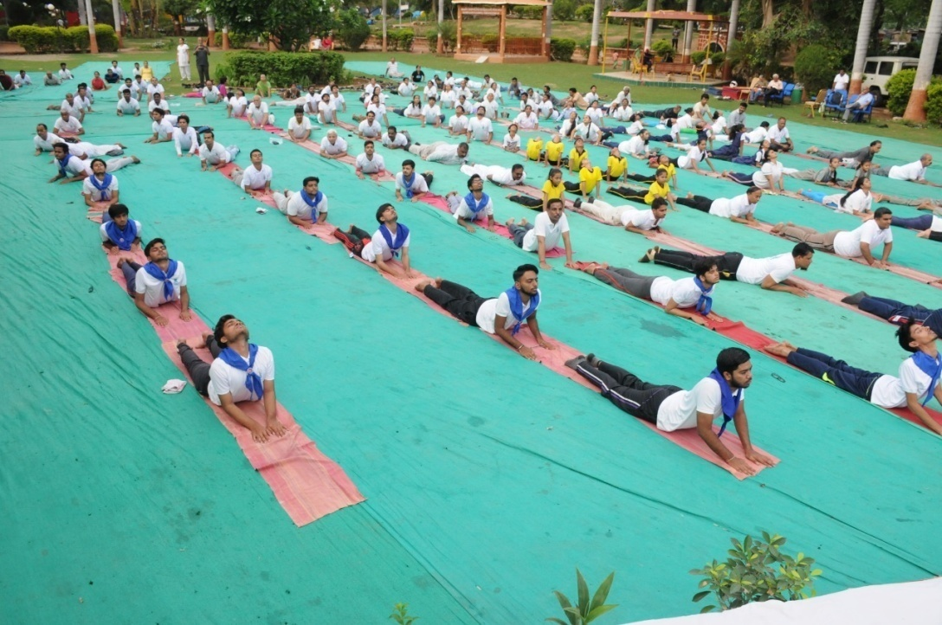
Celebration of International Yoga Day at Prahladnagar Garden,
ROB, Lucknow:

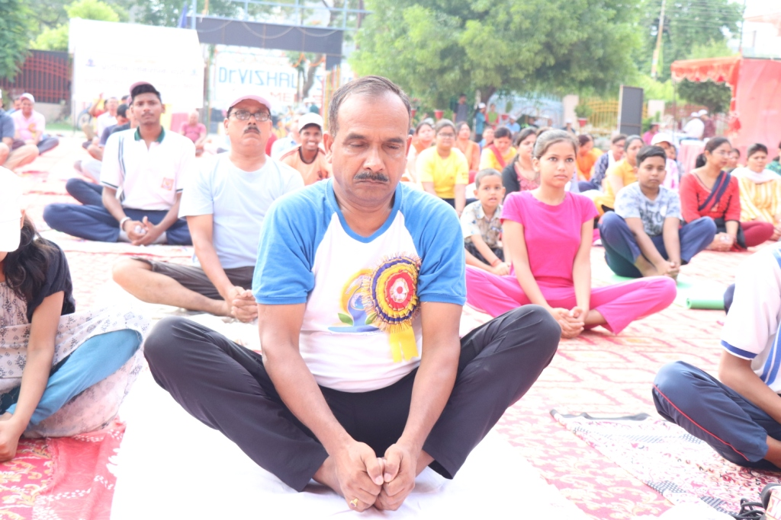
Celebration of International Day of Yoga at ROB, Lucknow

ROB, Bangalore:

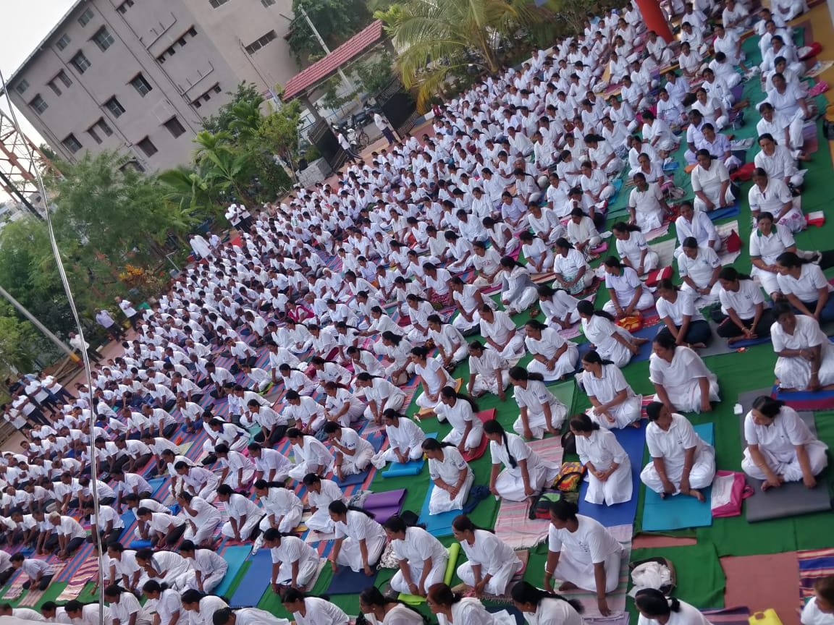
View of Participants at IDY programme organized in Shivamogga on 21.06.2019

ROB, Bhopal:
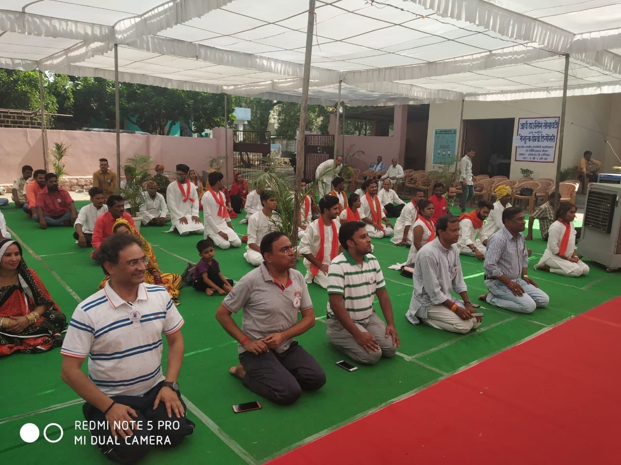
Yoga session at Regional Outreach Bureau, Bhopal

ROB, Dehradun:

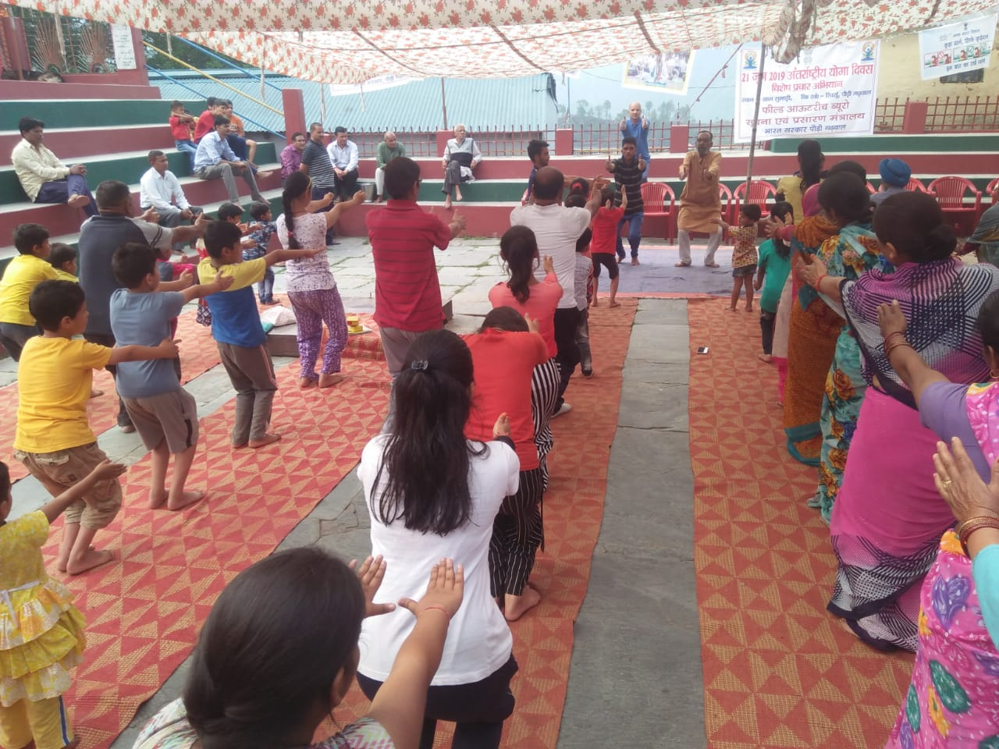
Yoga session on International Yoga Day at Dehradun
ROB, Hyderabad:

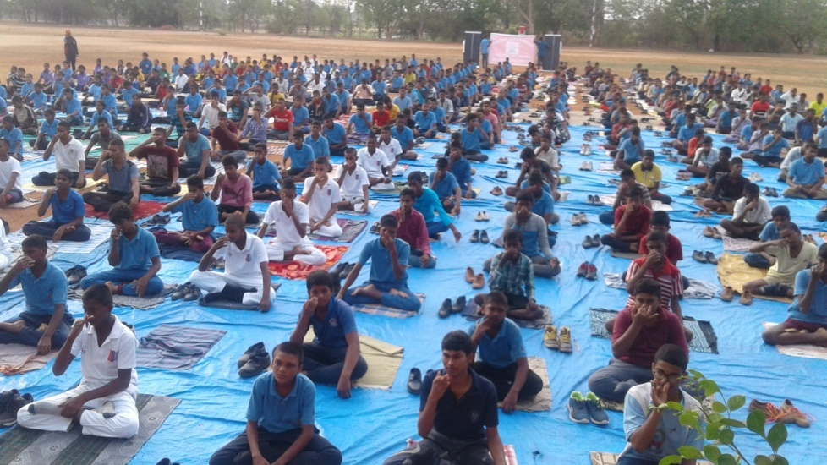
Yoga Asana practice session of participants at Ramanagar, Nalgonda

ROB, Itanagar:

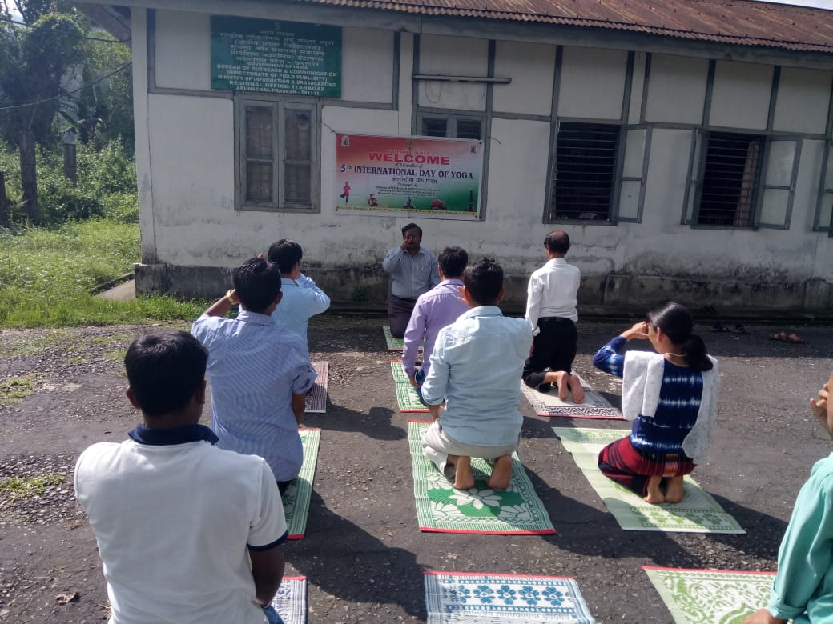
Yoga demonstration by Director ROB, Itanagar
ROB, Jaipur:

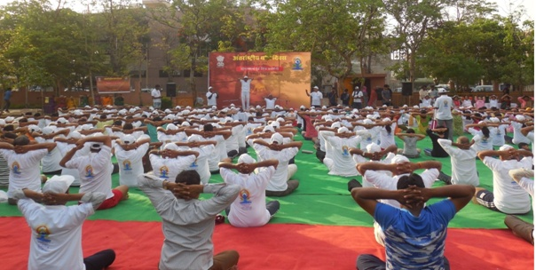
International Yoga Day at Jaipur

ROB, Pune:

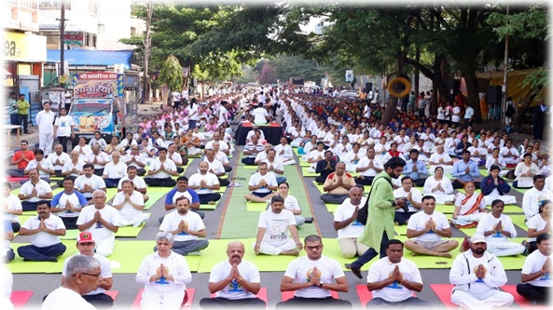
A view of Pune Yoga Street

ROB, Raipur:

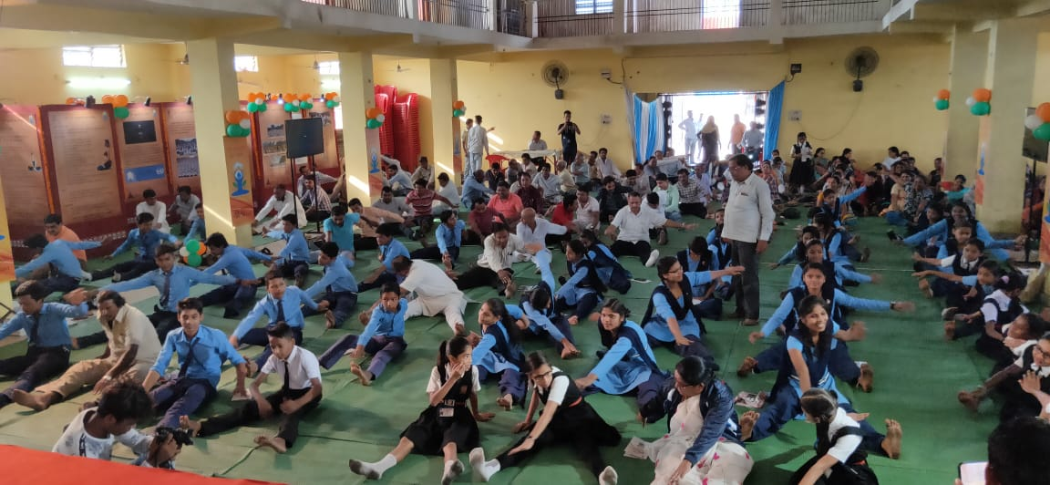
Yoga performed on 21st June at Birgaon during photo exhibition.

ROB, Siliguri:

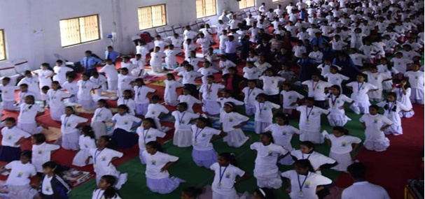
Gathering of masses during the IDY Programme of ROB, Siliguri.

ROB, Kolkata:

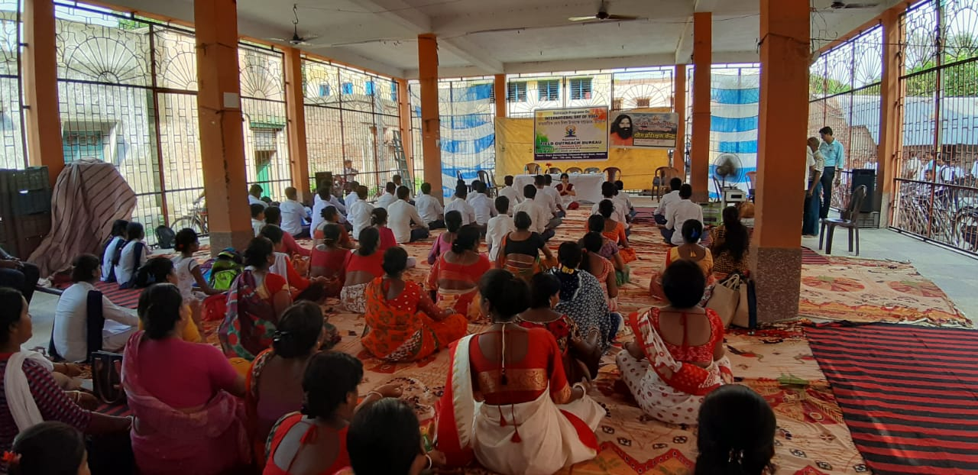
Celebration of International Day of Yoga, ROB Kolkata

ROB, Imphal:

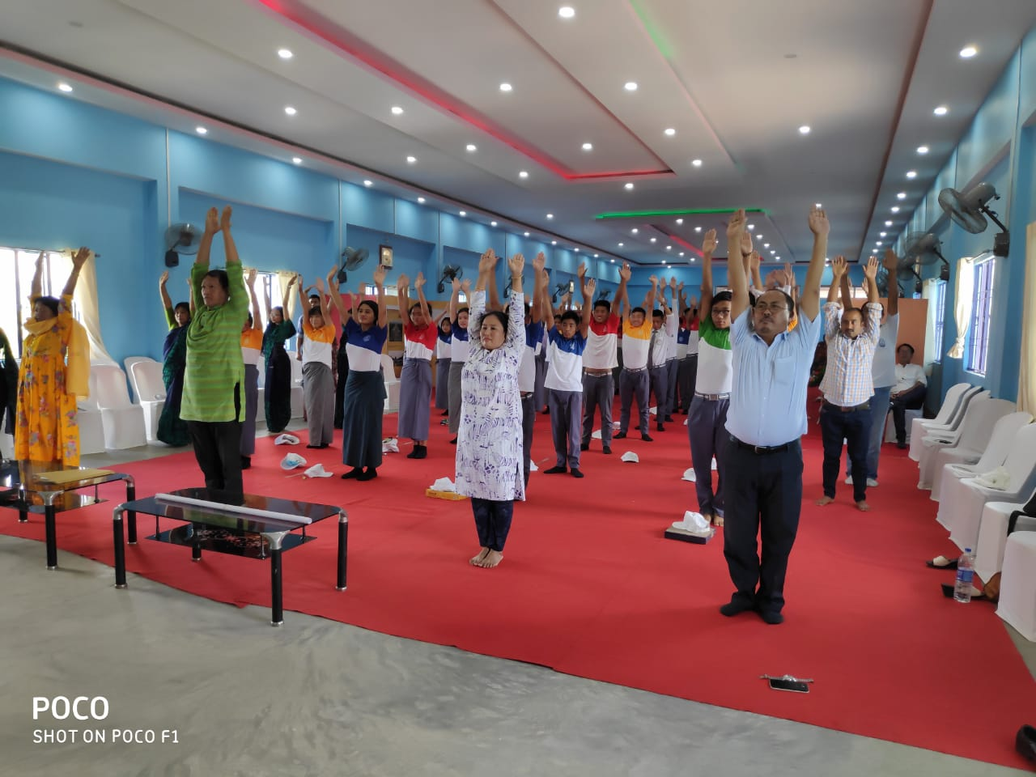
Celebration of International Day of Yoga at Imphal

- A half page color advertisement in 200 newspapers and a quarter page color advertisement in 2018 newspapers across India was released on 20.06.2019 & 21.06.2019 to create awareness on 5th International Day of Yoga 2019.

World Environment Day on 5th June, 2019

- World Environment Day 2019 was celebrated on 5th June, 2019 at BOC Hqrs. and at Regional Outreach Bureaus (ROBs) and Field Outreach Bureaus (FOBs) across India. DG: BOC, in the presence of senior officers and staff of BOC undertook the initiative of plantation of saplings at the office premises near gate No. 2 of the Soochna Bhavan at 03:30 P.M.

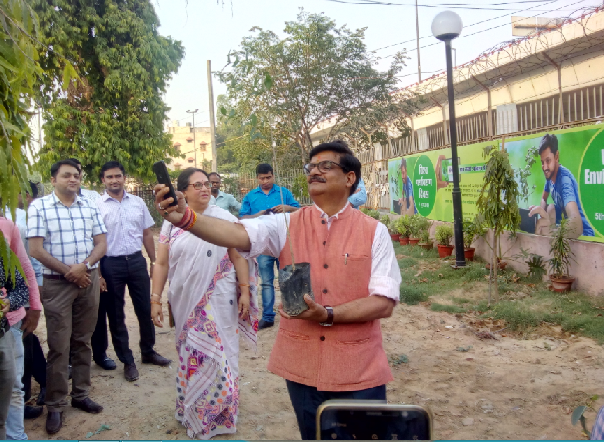

DG:BOC planting saplings near gate No.2 Soochna Bhavan

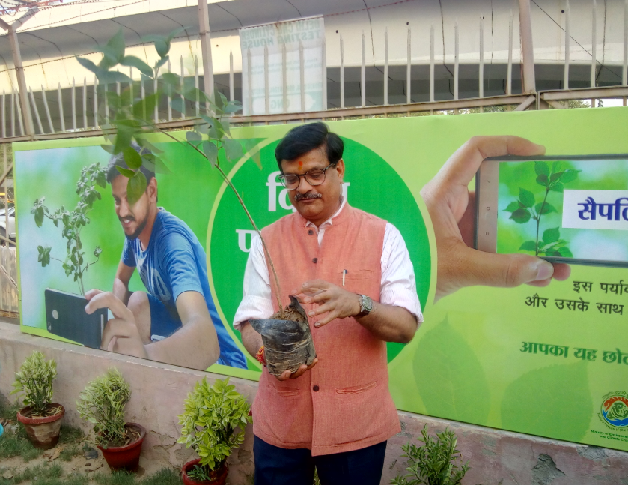
DG:BOC planting saplings near gate No.2 Soochna Bhavan

ROB, Chandigarh:

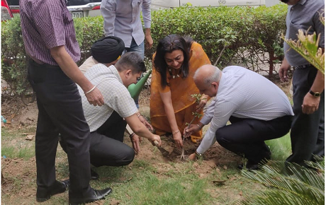
ADG (R) Smt. Devpreet Singh and Director Sh. Ashish Goyal planted saplings in the office premises at Kendriya Sadan Chandigarh.

ROB, Bangalore:

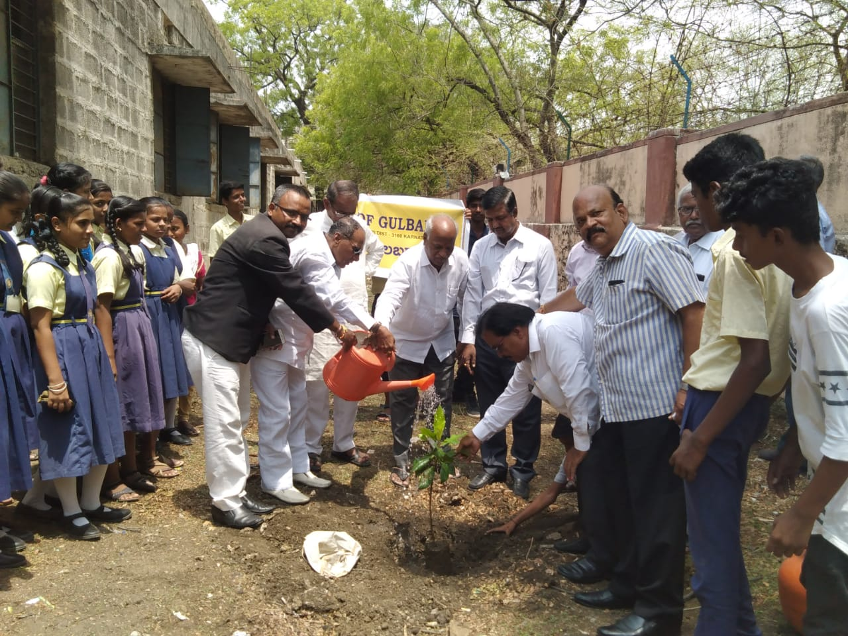
World Environment Day Prog. organized at Gulbarga on 06.06.2019.

ROB, Bhubaneswar:

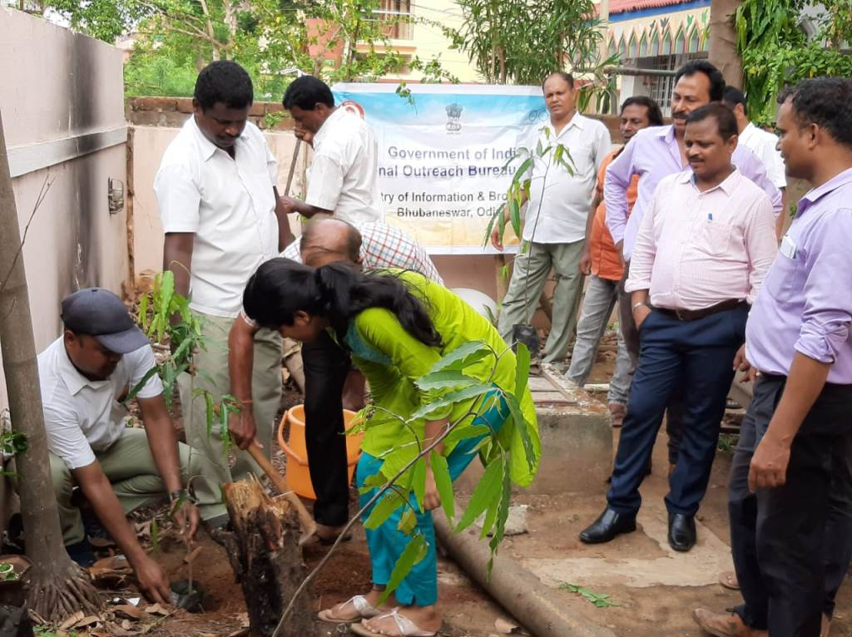
Plantation of saplings ROB, Bhubaneswar

ROB, Ahmedabad:

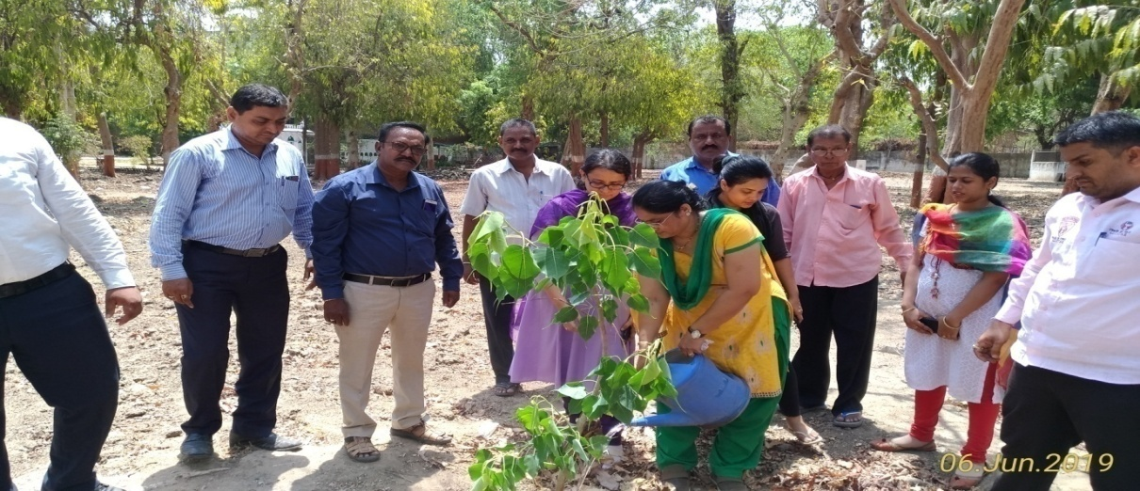
Plantation of saplings at ROB, Ahmedabad

- One strip color advertisement titled Selfie with Sapling on the occasion of World Environment Day 2019 was released in 68 newspapers across India.

INDIAN CINEMA Exhibition:

- The programme was organized In preparation of Golden Jubilee for Indian International Film Festival (IIFF), BOC organized an exhibition titled – INDIAN CINEMA on 28.05.2019 at Siri Fort Auditorium, New Delhi. The exhibition was inaugurated jointly by Mr. John Bailey and Shri. Amit Khare, Secretary, Ministry of I&B. Film dignitaries, senior officers of I&B Ministry and media heads visited the exhibition and appreciated it.

- On the Sidelines of the visit of Mr. John Bailey, President of Academy of Motion Picture of Arts & Science, Directorate of Film Festival (DFF) organized an interactive programme and other activities. On the request of Directorate of Film Festival (DFF) an exhibition with 80 display panels was organized by Bureau of Outreach & Communication.

Desh Ka Mahatyohar Campaign

- To create awareness among the general masses for their maximum participation in the General Election 2019, BOC run campaign across media viz. Print, Audio-Visual, Outdoor Media, New Media. The campaign continued during the entire month of April, 2019 on one or the other platforms. These awareness campaigns were run on behalf of Election Commission of India.

- Massive and intensive Outdoor Media campaign was undertaken for the Elections. The one month campaign was released on 1st April 2019 with emphasis on the Systematic Voter’s Education and Electoral Participation (SVEEP) voter awareness among various target groups such as Armed Personnel, Youth, elderly, first time voters etc. The theme of the campaign was ‘Desh Ka Mahatyohar’.

- BOC released print advertisements with various taglines. These included “Voter Awareness”, “My vote is not for sale”. Advertisements were mainly having messages with awareness about the democratic process of India and the on going Parliament Election 2019. The awareness campaign of Election commission through its creative designs targeted different sections of society i.e. Farmers, Women, Youth, Working class, Armed force Personnel, Elderly people etc. Various Voter Awareness Campaigns carried out for Loksabha Election-2019 involving themes viz: Accessible Election-Motivational, LS- Service Voter, Accessible Election –Athlete, ETPBS-Service Voters, LS-1950, Bharat Ki Misaal, EVM-VVPAT Animation, VVPAT Awareness, LS-Facilitation at PS, Accessible Election-Family, LS-Informed and Ethical Voting, Hum Vote Dene jayenge Desh Ke Liye

Integrated Communication& Outreach Programmes (ICOPs) :-
597 Integrated Communication& Outreach Programmes (ICOPs) were organized by FOBs/ROBs in all parts of the country including border areas, LWE affected areas and minority populated areas. Themes of ICOPs are: International Day of Yoga, Swachh Bharat Mission, Beti Bachao Beti Padhao, 100 Days of Union Government 2.0, Water conservation/ Jal Shakti Abhiyan, P.M. Jan Aushadhi Yojna, Swacchta hi Seva – Plastic Waste Management Campaign, Nutrition - Poshan Maah / National Nutrition Week, Fit “India, 150thBirth Anniversary of Mahtma Gandhi, 550th Birth Anniversary of Guru Nanak Dev Ji. Other themes for awareness programmes were:- Sukanya Samriddhi Yojana (SSY), Deen Dayal Upadhyaya Grameen Kaushalya Yojana, PM Ujjawala Yojana, PM Social Security Yojana, Rural Electrification Scheme, Transforming India, National Nutrition Mission, Ayushman Bharat health insurance scheme.

Awareness material on flagship Government schemes in the shape of booklets and posters were distributed during the programmes besides screening popular film shows. Debates, seminars, quiz contests, Cultural activities, students’ rally, and interactive communication sessions are also being held to propagate various components of the flagship programme of the Government. Feedback is also being obtained on the initiatives of Govt. policies and programmes.

Poshan Maah – Nutrition Month:-

FOBs/ROBs observed the Poshan Maaah during September, 2019 and conducted 58 Integrated Communication & Outreach Programmes (ICOPs) on importance of POSHAN Abhiyaan (National Nutrition Mission) with a message to improve nutritional status of children up to 6 years, adolescent girls, pregnant women and lactating mothers to achieve specific targets for reduction in low birth weight babies, stunting growth, under nutrition and prevalence of anemia.
Besides ICOPs, 291 Film shows, 749 Oral Communication programmes, 378 Photo exhibitions and collected 51 feedback responses by FOBs from the target audience

Programmes on Minority Welfare:-

Field Outreach Bureaus (FOBs) of BOC conducted awareness programmes during the period from April to September,2019 on Systematic Voters' Education and Electoral Participation (SVEEP) to educate citizens, electors and voters about the electoral process in order to increase their awareness and participation in the electoral processes, Swachh Bharat Abhiyan, Beti Bachao Beti Padhao, Water Conservation / Jal Shakti Abhiyan, World Population Day, Kargil Vijay Diwas, P.M. Jan Aushadhi Yojna, Quit India Movement, Independence Day Celebration, 150th Birth Anniversary of Mahatma Gandhi, 550th Birth Anniversary of Guru Nanak Dev Ji., 100 Days of Union Government 2.0 and Swachhta hi Sewa – Plastic Waste Management Campaign and other flagship schemes of the Government in minorities’ concentrated areas across the country have also been carried out by the FOBs to sensitize the masses about policies and programmes of Government.

Interpersonal communication in the form of Group Discussions, question- answer sessions, public meetings, Rally, Quiz contest, film shows were also held in minority concentrated areas with active participation of the target beneficiaries.

The details of the activities conducted by FOBs/ROBs in minority’s concentrated areas are as under:

Sr. | Activities | Nos.
1 | No. of Programmes conducted | 343
2 | Film shows | 229
3 | OC/GD | 379
4 | Photo Exhibition | 235
5 | Feedback stories | 119
6 | Villages covered | 299
7 | Audience Outreached | 114876

Publicity activities in Left Wing Extremism (LWE) affected areas:-

Field Outreach Bureau Units under nine Regional Outreach Buerau of Andhra Pradesh, Bihar, Chhattisgarh, Jharkhand, Maharashtra, Madhya Pradesh, Odisha, Uttar Pradesh and West Bengal (South) took up the task of awareness generation on all major programmes /schemes of the Government of India in areas affected by Left Wing Extremism.

Besides SOPs, 547 routine awareness programmes have been organized till October, 2019 by Field Outreach Bureaus (FOBs) of BOC in LWE areas which included 263 Film shows, 540 Oral Communication programmes, 337 Photo exhibitions and collected 131 feedback responses from the target audience.

Regional Outreach Bureaus presented 237 folk programmes in 90 LWE affected districts. During presentation of programmes the themes of Anti-terrorism, National Integration and Communal Harmony, Social Harmony, Linguistics Harmony, Beti Bachao Beti Padhao, Sabka Saath-Sabka Vikash, Gramin Vikash and developmental policies / schemes of the Government adopted for the welfare of the people.

Border Area Publicity Activities:-
Field Outreach Bureau under Regional Outreach Buerau of Arunachal Pradesh, Assam, Bihar, Gujarat, Jammu & Kashmir, Meghalaya-Mizoram-Tripura (MMT), Nagaland & Manipur, North-West (Punjab, Haryana and Himachal Pradesh), Rajasthan, Uttar Pradesh, Uttarakhand, West Bengal (North) & Sikkim & West Bengal (South) carried out publicity campaigns in border areas under their jurisdiction. The units briefed the border area villagers about the different schemes implemented by the Government of India. Special emphasis was laid on promoting National Integration and Communal Harmony.

Observation of important National and International Events/Days/Week:-

The Field Outreach Bureaus (FOBs) under Regional Outreach Bureaus (ROBs) also highlighted various schemes of the Government in its routine activities while observing important National and International events/Days/weeks. Anti terrorism Day, World No Tobacco Day, World Environment Day, International Yoga day, World Population Day, Kargil Vijay Diwas, Quit India Movement, Independence Day Celebration, Sadbhavna Diwas/week, 150th Birth Anniversary of Mahatma Gandhi,Gandhi Jayanti, International Day of Non-Violence,National Unity Day etc were observed

1 | No. of Film Show organized | 3412
2 | No. of Group Discussions organized | 7994
3 | No. of Photo Exhibitions mounted | 5391
4 | No. of Feedback Stories Collected | 1248
5 | No. of Villages Covered | 4099
6 | Total Audience outreached | 3185144

BOC has printed a total of 6,42,500 copies of Booklet, Poster, Folder and misc items in Hindi and English language during the month of April, 2019 to November,2019.

Name of Job | No. of Jobs | No. of Items | No. of Copies
Booklets | 21 | 22 | 2,00,900
Poster | 1 | 15 | 3,00,000
Folder | 6 | 7 | 35,800
Misc. | 8 | 8 | 1,05,300
Total | 36 | 52 | 6,42,000

Major Jobs Produced during the year
S. No. | Name of the Job
1. | Coffee Table Book for Vice President Secretariat
2. | Booklet on PM Speech (Naya Bharat)
3. | Booklet on 5 Trillion Dollar Indian Economy
4. | Booklet on Fifty Days of Modi Govt. (Jan Connect)
5. | Envelopes for PM Speech Books
6. | Jan connect Booklet (75 Days of Modi Govt.)
7. | 100 Days Booklet with Envelope
8. | Jan Connect Booklet (75 Days of Modi Govt.)-Addl. copies
9. | Pocket Size Booklet on 100 days
10. | 100 Days Booklet- Additional copies
11. | Folder on Loh Purush
12. | Indian Panorama Regulations Booklet 2019
13. | Brochure for M/o I&B
14. | Brochure for D.P. Kohli Memorial Lecture
15 | Information Leaflets for IAF(DISHA)
16. | Security Posters for DG, Military Intelligence (Army)
17. | ‘The Cadet’ Magazine for NCC
18. | Clicker Pen for Army DG, Recruiting
19. | Printing of Hardbound Folder and Certificate
20. | Booklet on Gandhi @150 & Guru Nanak
21. | Flyers on Women Empowerment (Hindi & English)
22. | Programme schedule of release of book on President of India
23. | Booklet on Howdy Modi
24. | Customized Coffee Mugs for EPFO
25. | Pens for EPFO
26. | Booklet for EPFO
27. | Booklet VRP & NSA
28. | NPC Corporate Brochure
29. | Discussion Paper Booklet
30. | Appeal by DG, BOC on Hindi Diwas
31. | Appeal by HMIB on Hindi Diwas
32. | Booklet on Record on Discussion
33. | Booklet on Chandrayaan-2
34. | Booklet on Guru nanak Dev ji
35. | Airforce Day Booklet
36. | Coffee Table Book for DISHA

